##### 

VOICE BASED INTILEGENT VIRTUAL ASSISTANT

FOR WINDOWS

A PROJECT REPORT

###### ***Submitted by***

##### MALA.M

##### [REGISTER NO: 211417104140]

##### BHUVANESHWARI.S

##### [REGISTER NO: 211417104313]

##### S.SELVA SHANKARI

##### [REGISTER NO: 211417104329]

**In partial fulfillment for the award of the degree**

**of**

BACHELOR OF ENGINEERING

IN

COMPUTER SCIENCE AND ENGINEERING

PANIMALAR ENGINEERING COLLEGE, CHENNAI-600123

ANNA UNIVERSITY: CHENNAI 600 025

**APRIL & 2021**

**BONAFIDE CERTIFICATE**

## Certified that this project report **“………VOICE BASED INTELLEGENT VIRTUAL ASSISTANT FOR WINDOWS………”is the bonafide work of”…….MALA.M (2114107104140), BHUVANESHWARI.S (211417104313), S.SELVA SHANKARI (211417104329)…….”** who carried out the project work under my supervision.

**SIGNATURE SIGNATURE**

**Dr.S.MURUGAVALLI,M.E.,Ph.D., Mrs.SANGEETHA KRISHNAN**

**HEAD OF THE DEPARTMENT SUPERVISOR**

**ASSISTANT PROFESSOR**

DEPARTMENT OF CSE, DEPARTMENT OF CSE,

PANIMALAR ENGINEERING PANIMALAR ENGINEERING

COLLEGE, COLLEGE,

NASARATHPETTAI, NASARATHPETTAI,

POONAMALLEE, POONAMALLEE,

CHENNAI-600123. CHENNAI-600123.

Certified that the above candidate(s) was/ were examined in the Anna University Project Viva-Voce Examination held on **August 2021**

**INTERNAL EXAMINER**  **EXTERNAL EXAMINER**

**ACKNOWLEDGEMENT**

We express our deep gratitude to our respected Secretary and Correspondent **Dr.P.CHINNADURAI, M.A., Ph.D.** for his kind words and enthusiastic motivation, which inspired us a lot in completing this project.

We would like to extend our heartfelt and sincere thanks to our Directors **Tmt.C.VIJAYARAJESWARI**, **Dr.C.SAKTHIKUMAR, M.E.., Ph.D.,** and **Tmt. SARANYASREE SAKTHIKUMAR B.E.,M.B.A.,** for providing us with the necessary facilities for completion of this project.

We also express our gratitude to our Principal **Dr.K.Mani, M.E., Ph.D.**for his timely concern and encouragement provided to us throughout the course.

We thank the HOD of CSE Department, **Dr. S.MURUGAVALLI, M.E.,Ph.D.,** for the support extended throughout the project.

We would like to thank our **Project Guide Mrs.SANGEETHA KRISHNAN** and all the faculty members of the Department of CSE for their advice and suggestions for the successful completion of the project.

##### 

##### NAME OF THE STUDENTS

##### 

##### MALA.M

##### BHUVANESHWARI.S

##### S.SELVA SHANKARI

**ABSTRACT**

PDAs (Personal Digital Assistants) also known as virtual assistants enhances a user’s productivity by proactively providing the information the user needs in the right context (i.e., time and place)PDAs reactively answers a user’s questions and completes the tasks through natural language. PDAs are now also deployed in tablets, laptops, desktop PCs, and headless devices (e.g., Amazon Echo), and some are also even integrated into operating systems. PDAs make use of some core set of technologies, such as machine learning, speech recognition, LU, question answering (QA) and personalization. The scenarios that the PDAs support can be divided into proactive and reactive assistance. Even though proactive and reactive parts of the current PDA architectures are built in isolation, in principle they can use a single architecture to enable both types of experiences. PDAs are complex systems with many components in the system stack, spanning client and multiple cloud services, and it is hard to separate any one component from the rest.

TABLE OF CONTENTS

| **CHAPTERNO.** | **TITLE** | **PAGE NO.** |
| --- | --- | --- |
|  | **ABSTRACT** | 4 |
|  | **LIST OF FIGURES** | 7 |
|  | **LIST OF SYMBOLS, ABBREVIATIONS** | 8 |
| **1.** | **INTRODUCTION** |  |
|  | 1.1 Overview | 9 |
|  | 1.2 Problem Definition | 10 |
| **2.** | **LITERATURE SURVEY** | 11 |
| **3.** | **SYSTEM ANALYSIS** |  |
|  | 3.1 Existing System | 15 |
|  | 3.2 Proposed system | 18 |
|  | 3.3 Hardware Environment | 19 |
|  | 3.4 Software Environment | 19 |
|  | 3.5 Software Specification | 20 |
|  | 3.5.1 Flask | 20 |
|  | 3.6 Anaconda | 21 |
|  | 3.6.1 Installation Procedure | 25 |
| **4.** | **SYSTEM DESIGN** | 29 |
|  | 4.1. Use-Case Diagram | 30 |
|  | 4.2 State Diagram | 31 |
|  | 4.3 Collaboration Diagram | 32 |
|  | 4.4 Activity Diagram | 33 |
|  | 4.5 Sequence Diagram | 34 |
| **5.** | **SYSTEM ARCHITECTURE** |  |
|  | 5.1 Architecture Overview | 35 |
|  | 5.2 Module Design Specification | 36 |
| **6.** | **SYSTEM IMPLEMENTATION** |  |
|  | 6.1 Camera | 38 |
|  | 6.2 Main | 40 |
|  | 6.3 Install with extract steps | 44 |
| **7.** | **SYSTEM TESTING** |  |
|  | 7.2 Test Data And Output | 70 |
|  | 7.2.1 Unit Testing | 70 |
|  | 7.2.2 Functional Testing | 70 |
|  | 7.2.3 Performance Testing | 71 |
|  | 7.2.4 Stress Testing | 71 |
|  | 7.2.5 Structured Testing | 71 |
|  | 7.2.6 Integration Testing | 71 |
|  | 7.3 Testing Techniques / Testing Strategies | 72 |
|  | 7.4 Coding | 76 |
|  | 7.5 Coding Standards | 77 |
| **8.** | **CONCLUSION** |  |
|  | 8.1 Conclusion and Future Enhancements | 79 |
| **9.** | **APPENDICES** |  |
|  | A.1 Sample Screens | 80 |
|  | A.2 Publications | 97 |
| **10.** | **REFERENCES** | 104 |

**LIST OF FIGURE**

|  |  |  |
| --- | --- | --- |
| **FIGURE NO** | **FIGURE NAME** | **PAGE NO** |
| 1 | Anaconda Navigator | 26 |
| 2 | Installation Of Anaconda Packages | 27 |
| 3 | Use-case Diagram | 30 |
| 4 | State Diagram | 31 |
| 5 | Activity Diagram | 32 |
| 6 | Collaboration Diagram | 33 |
| 7 | Sequence Diagram | 34 |
| 8 | System Architecture Diagram | 35 |

**LIST OF SYMBOLS, ABBREVIATIONS**

**PDA** -Personal Digital Assistants

**MOSTI** - Ministry of Science, Technology and Innovation

**ERP** - Enterprise resource planning

**IPA** - intelligent personal assistant

**VISI** - visually impaired learner.

**CHAPTER 1**

**INTRODUCTION**

* 1. **OVERVIEW**

The Voice recognition technology system was developed before the Apple’s Siri was introduced in 2012. In 1963 at the Seattle World’s Fair IBM delivered a tool named Shoe box. It can easily find and recognize 1,011 words, which is equal to the vocabulary knowledge of a 3 year old student. It was actually like the size of a shoebox and performs some mathematical operations and can easily recognize 16 spoken words and also digits from 0-9.The rapid growth of machine learning and Artificial Intelligence which made possible the growth and development of voice recognition methodology. There is a lot of human beings exists in this society who uses speaking. An average human can be able to pronounce about 150 words in a minute, but can only type 40 words. This explains why voice technology should be taken immediately by IT companies. It takes a lot time for human to write a paragraph than reading it. This project is based on voice intelligent Assistance. This tool is used for searching purposes, remainders just by using voice commands. If we want to access any document or file we can do it by voice recognition. But there are certain limitations that the user should set some voices as a security options. If the user spells out the word it automatically types in the required field. It recognizes the speech and searches the appropriate content in the database and retrieves it. The user should select the appropriate language for the virtual assistant to understand. If any wrong or invalid communication happens it invokes some messages in dialog box. It is like a software agent who performs tasks and events based on commands. Voice-Command and speech synthesis are enhancing the level of user-interaction in applications. This trend is now approaching business-applications like ERP-Systems. Implementing an intelligent personal assistant (IPA) will empower the application not only by navigating users through the system, but it also enables the option to navigate and explain data to the users through speech synthesis.

In the last decade internet has introduced itself as the most important media. There are million pages of useful information available for users to obtain specific information in different fields. Users are able to access information on a wide variety of subjects from anywhere, anytime. This has made Internet as the fastest and easiest media to access at this period of time. On the other hand, there is a need to look at new innovative tools to make the Internet A more reliable media for all types of users, particularly, the visually impaired. An effective browser I needed to make the Internet more accessible to visually impaired learners. It is with this in mind that a group of researchers through a grant obtained from the Ministry of Science, Technology and Innovation (MOSTI), conducted a research in collaboration with the Malaysian Association of the Blind (MAB) to develop a voice recognition browser called Mg Sys VISI for the visually impaired learner.

* 1. PROBLEM DEFINITION

With the development of technology growing day by day, there is much advancement in the computer field. The people who are suffering from blindness couldn’t able to operate the computer even though they gained knowledge in computer. So to help them, we are implementing voice based recognition system

CHAPTER 2

LITERATURE SURVEY

A literature survey is the documentation of a comprehensive review of the publishers and unpublished work from the secondary sources data in the areas of specific interest to the researchers. It provides an overview of current knowledge, allowing you to identify relevant theories, methods, and gaps in the existing research. Conducting a literature review involves collecting, evaluating, and analyzing publications (such as books and journal articles) that relate to the research question.

Many research works are carried out in the voice based recognition system. The recently carried works have been explained in detail below.

1. “Interacting with Embodied Conversational Agents”, Elizabeth Andre,

Catherine Pelachaud.

It focuses to develop more human-centered, personalized and more engaging speech-based interactive systems immediately leads to the embodied conversational agent (ECA) that employs gestures, mimics and speech to communicate with the human user.

**Advantages:**

Gesture recognition has gained Considerable attention in emerging Applications

To provide a better user experience for human- computer interaction.

**Disadvantages:**

These solutions are either easily affected by the Environmental noise or incapable

of sensing fine-grained gestures at the finger level.

2.” Voice based Intelligent Virtual Assistance for Windows”, C.Selvarathi, Dr. B. Padminidevi.

The proposed system was based on the voice recognition in commands which converts the speech to text. It uses LGB algorithm functions which will train the VQ codebook.

**Advantages:**

It converts text to speech .It will assist you to find the applications easily. It can be used in windows 7.

**Disadvantages:**

Data need to be entered properly otherwise outcome may won’t be accurate. The user who are deaf and dumb cant able to access this.

3.” The Technology behind Personal Digital Assistants”, Ruhi Sarikaya,

It focuses on enhancing a user’s productivity by proactively providing the information the user and reactively answering a user’s questions and completing tasks through natural language.

**Advantages:**

Expanded association.

Broad Internet Connectivity.

**Disadvantages:**

Operation errors.

Lack of competence.

Speech recognition challenges.

4.” Web-based environment for user generation of spoken dialog for virtual assistants”, Ryota Nishimura , Daisuke Yamamoto, Takahiro Uchiya and Ichi Takumi.

It focuses on a web-based spoken dialog generation environment which enables users to edit dialogs with a video virtual assistant is developed and to also select the 3D motions and tone of voice for the assistant.

**Advantages:**

Allows anyone to easily edit spoken dialog content and other virtual video assistant features such as tone of voice, facial expression, and body motion.

**Disadvantages:**

Detailed information can be difficult to convey using.

Users may be unaware of what topics they can talk about.

5. mmdaget - a fully open-source toolkit for voice interaction systems okiso-cho, showa-ku, nagoya,

It focuses on development of an open-source toolkit which makes it possible to explore a vast variety of aspects in speech interactions at spoken dialog systems and speech interfaces.

**Advantages:**

On-line speaker interpolation is supported, so one can merge several speaker model at run time to produce speech of various speaking styles.

**Disadvantages:**

Existing datasets have been collected under controlled laboratory conditions and methods have been not evaluated across multiple datasets.

**CHAPTER 3**

**SYSTEM ANALYSIS**

**3.1 EXISTING SYSTEM**

In order to overcome the problems faced by the visually impaired learners, a solution in the form of a specialized voice recognition browser and marking system called the Mg Sys VISI was designed using the iterative software engineering participatory method where the visually impaired learners from the Malaysian Association of the Blind (MAB) were part of the active collaborator of the development process. The model of the system takes into consideration the Virtual Learning and Cognitive theories. The objectives of the research were as follows: The methodology is as indicated in Figure 1. i. To design and develop an Internet browser that enables them to browse the Internet through a voice recognition system. ii. To develop the browser using a voice recognition application that allows the visually impaired learners to send and receive e-mails. iii. To develop a browser that allows the visually impaired learners to search for articles through a search engine and print the desired articles in Braille. iv. To develop a translation module that is able to convert Braille back to text to help teachers mark assignments of the visually impaired. The system was designed based on the Holistic Cognitive Voice Haptic Architecture (HCHVHA) model based on Cognitive theories Based on this model; the visually impaired learner can interact with the system through the use of the microphone. Graevenitz found from their research that a voice recognition system can be designed to contain features that can be speaker dependent, adaptive or independent. Mg Sys Visa was built based on the independent feature. Based on the HCVHA model, five modules were developed and they are as follows:

1. Automatic Speech Recognition Module (ASR)
2. Text-to-Voice Module (TTV)
3. Search Engine (SE)
4. Text-to-Braille (TTB) Braille-to-Text (BTT)

The Automatic Speech Recognition (ASR) is the first module found in the Mg Sys Visa for the visually impaired learners. The most important factor that needs to be taken into consideration with the ASR is the intersession variability and the variability over time [7], [8]. The changes can occur from the user themselves when they are recording their voice in a different place or the noise in the background of the place where the voice of the user is being recorded. The speaker normally is not able to repeat in the same manner with the same intonation at all times. However, it always better when a recoding is conducted straight at one time as compared to when recording is interrupted and continued at a different time. Two types of normalization exist that is: the parameter domain normalization and the Equalization domain technique. The former known as spectral equalization is also known as the blind equalization method [9]. This technique can reduce the linear channel and the long term spectral variation. This method is most effective for speaker dependent application where the speaker involved normally uses long sentences. This technique is not suitable for a speaker recognition that uses short words. The latter, however uses the likelihood ratio approach. The likelihood ratio is defined based on two situations to measure the style of speech spoken. The first likelihood is the acoustic data that could contribute to the recognition of the speaker and the second likelihood is the speaker could be an imposter. The normalization based on the posterior likelihood was also studied. The difference between the normalization based on the ratio likelihood and the posterior likelihood is to ensure that the claimed speaker is recorded for normalization [10]. Based on experiments carried out, both of the methods obtain almost the same level of effectiveness. Both methods allows the system to lessen the need to depend on only the claimed speaker. The Text-to Voice Module (TTV) includes the technology to synthesis speech of the speaker whereby the input in the form of text is converted automatically to the audio output in the form of voice [11],[12]. In the case of Mg Sys Visa, the TTV converts the html text codes through the html converter into voice codes. The main function of the TTV engine then, is to process the input text and converts it to the audio output and then played to the user. The level of vocabulary output of the TTV is based on the set of words spoken into the engine. The TTV engine comprises of two components: the text processor and the synthesizer. When a text is put into the engine, the text processor analyses the words, phrase or sentences that is put in. The system has to make rough semantic meaning. The text that has been normalized will be sent to the synthesizer to produce the sound heard by the visually impaired learner. The html converter changes the html codes into text.These so that the engine Text-to-Voice (TTV) can read the web content and meaningfully for the visually impaired learner. The converter will remove all the tags in the html codes and leave it as text only.

For example: Input:

This is an example of the conversion

Output: This is an example of the conversion

Apart from removing all the tagging, the role of the converter is also screen the pictures and graphics that cannot be converted into text

**3.2 PROPOSED SYSTEM**

In the proposed system, the voice is taken as the input and is considered as the convenient and efficient mode of communication. Most of the people prefer to use speech rather than using text based. The basic overview of the proposed system is it gets input signal in the form of voice. It passes on to the feature extraction and gets into the decoder. In the decoder it consists of two main models, they are acoustic model and language model. The decoder will decode the input. After all the processing going in the decoder it gives the specified output. The classifications of speech recognition system are types of speech utterance, types of speaker model, and types of vocabulary.

The proposed system is divided into 3 phases and the 3 phases are

* Speech to Text: User will ask the computer to run command by giving input as speech
* Command Execution: Based on command received from the user, system will execute the command (if available). e.g. Open Notepad, Paint, Google Chrome, etc. System accept various command such as opening of specific applications, writing a note and saving it, opening web URL, Search for any query or details and shutdown & Restart command
* Text to Speech: Once a command is received, application speaks the command which makes user experience more interactive with the system

|  |
| --- |
| **3.3 HARDWARE ENVIRONMENT**  Hard Disk : 500GB and Above  RAM : 4GB and Above  Processor : I3 and Above |
| **3.4 SOFTWARE ENVIRONMENT**  Operating System : Windows 7 , 8, 10 (64 bit)  Software : Python and Anaconda  Tools : Jupyter Note Book and Spyder IDE  .  **3.5 SOFTWARE SPECIFICATION**  **3.5.1 FLASK**  Flaskis a micro web framework written in Python. It is classified as a micro framework because it does not require particular tools or libraries. It has no database abstraction layer, form validation, or any other components where pre existing third-party libraries provide common functions. However, Flask supports extensions that can add application features as if they were implemented in Flask itself. Extensions exist for object-relational mappers, form validation, and upload handling, various open authentication technologies and several common framework related tools. Extensions are updated far more frequently than the core Flask program. Flask is a lightweight web frame of Python. It provides the user with libraries, modules and tools to help build Web-Applications such as a blog or wiki. It offers various features like:  • Development server and debugger  • Integrated support for unit testing  • RESTful request dispatching  • Uses Jinja templating  • Support for secure cookies (client-side sessions)  • 100% WSGI 1.0 compliant  • Unicode-based  • Extensive documentation  • Google App Engine compatibility  • Extensions available to enhance features desired  **3.6 ANACONDA**  Anaconda is a free and open-source distribution of the Python and R programming languages for scientific computing (data science, machine learning applications, large-scale data processing, predictive analytics, etc.), that aims to simplify package management and deployment. The distribution includes data-science packages suitable for Windows, Linux, and macOS. It is developed and maintained by Anaconda, Inc., which was founded by Peter Wang and Travis Oliphant in 2012. As an Anaconda, Inc. product, it is also known as Anaconda Distribution or Anaconda Individual Edition, while other products from the company are Anaconda Team Edition and Anaconda Enterprise Edition, which are both not free. Package versions in Anaconda are managed by the package management system conda.  **TENSORFLOW**  TensorFlow is a free and open-source software library for dataflow and differentiable programming across a range of tasks. It is a symbolic math library, and is also used for machine learning applications such as neural networks. It is used for both research and production at Google. TensorFlow was developed by the Google Brain team for internal Google use. It was released under the Apache License 2.0 on November 10 9, 2015. While the reference implementation runs on single devices, TensorFlow can run on multiple CPUs and GPUs (with optional CUDA and SYCL extensions for general-purpose computing on graphics processing units). TensorFlow is available on 64- bit Linux, macOS, Windows, and mobile computing platforms including Android and iOS. Its flexible architecture allows for the easy deployment of computation across a variety of platforms (CPUs, GPUs, TPUs), and from desktops to clusters of servers to mobile and edge devices. TensorFlow computations are expressed as stateful dataflow graphs. The name TensorFlow derives from the operations that such neural networks perform on multidimensional data arrays, which are referred to as tensors.  **KERAS**  Keras is an open-source neural-network library written in Python. It is capable of running on top of TensorFlow, Microsoft Cognitive Toolkit, R, Theano, or PlaidML. Designed to enable fast experimentation with deep neural networks, it focuses on being user-friendly, modular, and extensible. It was developed as part of the research effort of project ONEIROS (Open-ended Neuro-Electronic Intelligent Robot Operating System), and its primary author and maintainer is François Chollet, a Google engineer. Chollet also is the author of the XCeption deep neural network model. Keras contains numerous implementations of commonly used neural-network building blocks such as layers, objectives, activation functions, optimizers, and a host of tools to make working with image and text data easier to simplify the coding necessary for writing deep neural network code. The code is hosted on GitHub, and community support forums include the GitHub issues page, and a Slack channel. In addition to standard neural networks, Keras has support for convolutional and recurrent neural networks. It supports other common utility layers like dropout, batch normalization, and pooling. Keras allows users to productize deep models on smartphones (iOS and Android), on the web, or on the Java Virtual Machine. It also allows use of distributed training of deep learning models on clusters of Graphics processing units (GPU) and tensor processing units (TPU) principally in conjunction with CUDA.  **NUMPY**  NumPy is a library for the Python programming language, adding support for large, multi-dimensional arrays and matrices, along with a large collection of high- level mathematical functions to operate on these arrays. In Python we have lists that serve the purpose of arrays, but they are slow to process.NumPy aims to provide an array object that is up to 50x faster than traditional Python lists.The array object in NumPy is called ndarray, it provides a lot of supporting functions that make working with nd array very easy. Arrays are very frequently used in data science, where speed and resources are very important.  **OPENCV**  Python Opencv is a cross-platform library using which we can develop real-time computer vision applications. It mainly focuses on image processing; video capture and analysis including features like face detection and object detection. CV is the construction of explicit, meaningful descriptions of physical objects from their image. The output of computer vision is a description or an interpretation of structures in 3D scene. It is available for Windows, Mac OS X and Linux.  **PANDAS**  Pandas are a software library written for the Python programming language for data manipulation and analysis. In particular, it offers data structures and operations for manipulating numerical tables and time series. It is free software released under the three-clause BSD license. Pandas are a Python library used for working with data sets. It has functions for analyzing, cleaning, exploring, and manipulating data. The name "Pandas" has a reference to both "Panel Data", and "Python Data Analysis" and was created by Wes McKinney in 2008. Pandas allows us to analyze big data and make conclusions based on statistical theories.Pandas can clean messy data sets, and make them readable and relevant.Relevant data is very important in data science.  **SEABORN**  Seaborn is a library for making statistical graphics in Python. It builds on top of matplotlib and integrates closely with pandas data structures. Seaborn helps you explore and understand your data. Its plotting functions operate on dataframes and arrays containing whole datasets and internally perform the necessary semantic mapping and statistical aggregation to produce informative plots. Its dataset-oriented, declarative API lets you focus on what the different elements of your plots mean, rather than on the details of how to draw them.  **MATPLOTLIB**  Matplotlib is a low level graph plotting library in python that serves as a visualization utility.Matplotlib was created by John D. Hunter.Matplotlib is open source and we can use it freely.Matplotlib is mostly written in python, a few segments are written in C, Objective-C and Javascript for Platform compatibility. Matplotlib is an amazing visualization library in Python for 2D plots of arrays. Matplotlib is a multi-platform data visualization library built on NumPy arrays and designed to work with the broader SciPy stack. It was introduced by John Hunter in the year 2002. One of the greatest benefits of visualization is that it allows us visual access to huge amounts of data in easily digestible visuals. Matplotlib consists of several plots like line, bar, scatter, histogram etc.  **PYTORCH**  PyTorch is a library for Python programs that facilitates building deep learning projects. PyTorch emphasizes flexibility and allows deep learning models to be expressed in idiomatic Python. PyTorch is an open source machine learning library used primarily for applications such as computer vision and natural language processing. PyTorch is a strong player in the field of deep learning and artificial intelligence, and it can be considered primarily as a research-first library.  **3.6.1 INSTALLATION PROCEDURE**  Step 1 — Install the dependencies for Windows   1. Download & install Anaconda package 64-bit version and choose the Python 3.6 version. This automatically installs Python and many popular data scientist/ML libraries (NumPy, Scikit-Learn, Pandas, R, Matplotlib…), tools (Jupyter Notebook, RStudio) and hundreds of other open source packages for your future projects. For example, the Anaconda Jupyter Notebook is used for all experiments. OpenCV library is not included though and we will install it separately as it is needed for real-time computer vision tasks.         Fig. 3.1 Anaconda Navigator   1. Install Tensorflow and Keras. TensorFlow is the most popular AI software library and is created/maintained by Google. Keras is another highly popular & high-level neural networks API, written in Python and capable of running on top of TensorFlow. It was developed with a focus on enabling fast experimentation.       Fig. 3.2 Installation of Anaconda Packages  Step 2 — Install the Dtcwt.  Dtcwt: Originally, the dtcwt library provides a Python implementation of the 1, 2, 3-D dual tree complex wavelet transform along with the some associated algorithms. It contains a pure CPU implementation which makes use of NumPy along with an accelerated GPU implementation using OpenCL.  # Open your anaconda prompt and clone the dtcwt github repository. git clone https://github.com/fbcotter/dtcwt  # Alternative is to basically go to the dtcwt GitHub page and download the master repository to your local    # If you have not already created a new virtual environment in Step 1, then create a conda environment for dtcwt installation.  conda create -n your_env_name python=3.7  # Activate the new environment using anaconda prompt. activate your_env_name  # You can install the needed OpenCV with a conda-forge repository. conda-forge is a github organization containing repositories of conda libraries.  conda config --add channels conda-forge conda install opencv  # Build the Cython extensions in place. This is a widely used Python to C compiler and wrapper that helps us to call the dtcwt C-code from Python.  python setup.py build_ext –inplace or try the following as alternative pip install –e |
|  |

**CHAPTER 4**

**SYSTEM DESIGN**

The main purpose of the design phase is to plan solutions to the problems specified by the requirement document. The design phase takes as input the requirement in the Requirements Analysis stage. This phase is the step in moving from the problem domain to the solution domain. The design of the system is perhaps the most critical factor affecting the quality of the software, and has a major impact in the later phases, particularly in testing and maintenance. The output of this phase is the functional design document. The design documents created for the proposed system consists of the system architecture and the data flow diagram. This is also known to be the top-level design that identifies the modules in the system, and how the data transfer takes place between the modules. This chapter deals with design documents created for the proposed system which consists of functional architecture and activity diagrammatic. During detailed design, the internal logic of all the modules specified in the system design is decided. The system architecture deals with the components to be used in the proposed system which explains its interaction with one other. The data flow diagram describes the graphical representation of how the data flows between the different modules in the system. The data flow diagram gives a very clear picture of the flow of data among the working modules. These design documents are used as a continuous reference point for further system development and coding.

**4.1 USECASE DIAGRAM**

Use case diagrams consist of actors, use cases and their relationships. The diagram is used to model the system/subsystem of an application. A single use case diagram captures a particular functionality of a system. Hence to model the entire system, a number of use case diagrams are used. A use case diagram at its simplest is a representation of a user's interaction with the system that shows the relationship between the user and the different use cases in which the user is involved.

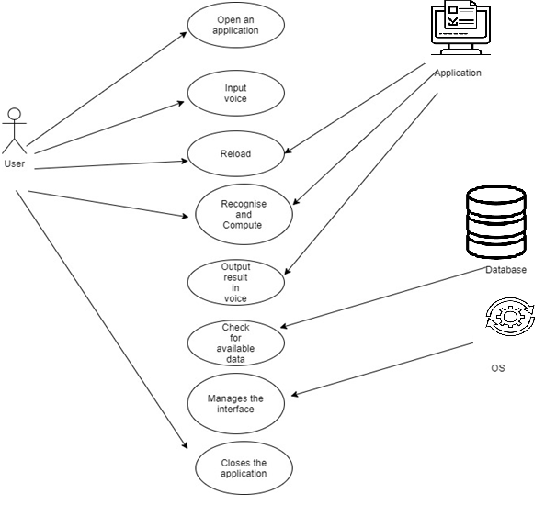

**4.2 STATE DIAGRAM**

A state diagram, sometimes known as a state machine diagram, is a type of behavioral diagram in the Unified Modeling Language (UML) that shows transitions between various objects. A state diagram shows the behavior of classes in response to external stimuli. Specifically a state diagram describes the behavior of a single object in response to a series of events in a system. ... This UML diagram models the dynamic flow of control from state to state of a particular object within a system.

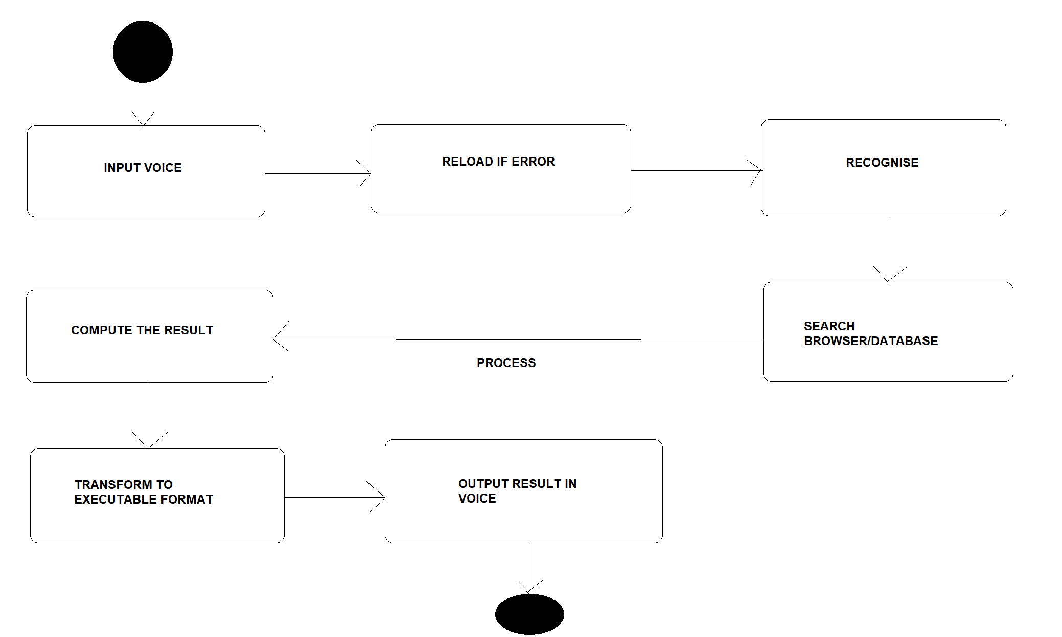

**4.3 COLLABRATION DIAGRAM**

A collaboration diagram, also known as a communication diagram, is an illustration of the relationships and interactions among software objects in the Unified Modeling Language (UML). These diagrams can be used to portray the dynamic behavior of a particular use case and define the role of each object.

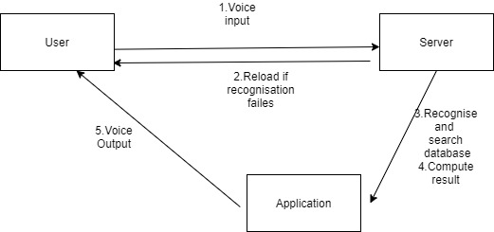

**4.4 ACTIVITY DIAGRAM**

Activity diagram is another important behavioral diagram in UML diagram to describe dynamic aspects of the system. Activity diagram is essentially an advanced version of flow chart that modeling the flow from one activity to another activity. An activity diagram visually presents a series of actions or flow of control in a system similar to a flowchart or a data flow diagram. Activity diagrams are often used in business process modeling. They can also describe the steps in a use case diagram. Activities modeled can be sequential and concurrent.

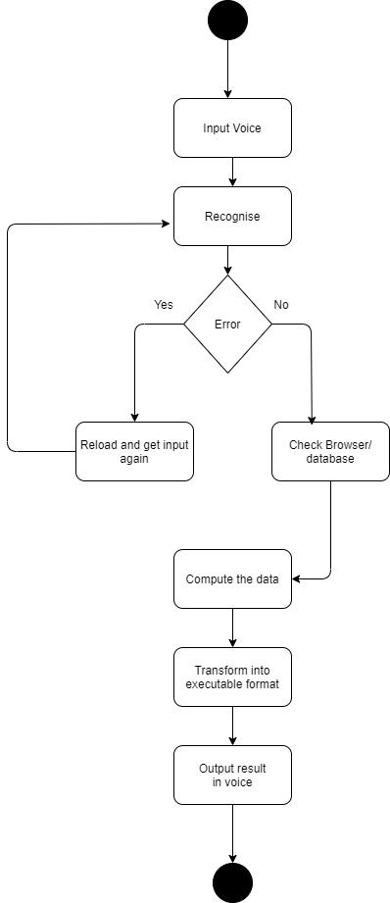

**4.5 SEQUENCE DIAGRAM**

A sequence diagram shows object interactions arranged in time sequence. It depicts the objects involved in the scenario and the sequence of messages exchanged between the objects needed to carry out the functionality of the scenario.. Sequence diagrams are sometimes called event diagrams or event scenarios.

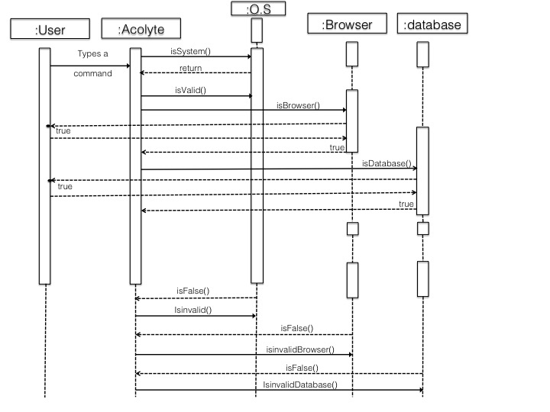

**CHAPTER 5**

**SYSTEM ARCHITECTURE**

**5.1 ARCHITECTURE OVERVIEW**

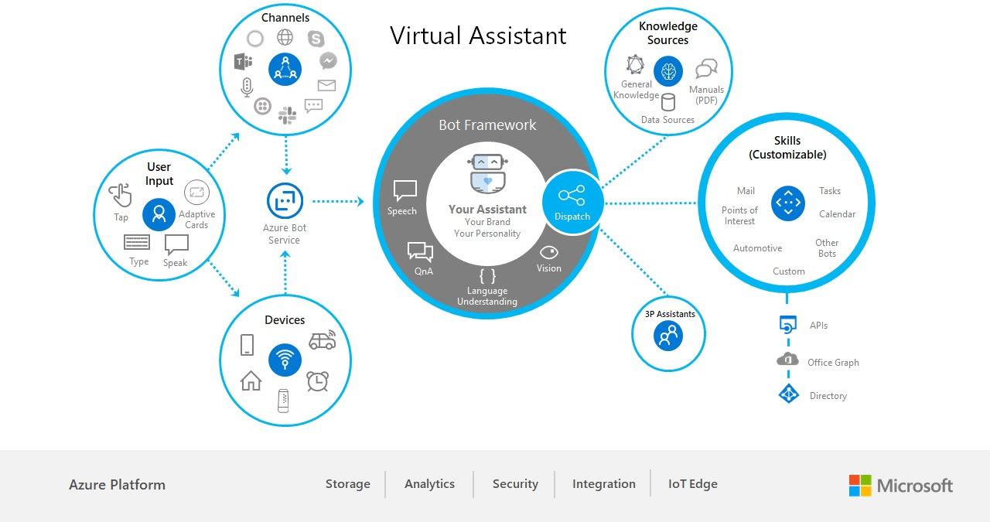

**5.2 MODULE DESIGN SPECIFICATION**

The modular structure defines the structure of the overall module. Modularity is a general concept typically defined as a degree to which a system’s components may be separated and recombined.

There are three modules in our project .The list of modules are as follows:

* Speech to text
* Command execution
* Text to speech

**MODULE 1: SPEECH TO TEXT MODULE:**

* User will ask the computer to run command by giving input as speech.
* The speech processing system includes a speech recognizer residing on a first computing device and a speech model server residing on a second computing device.
* The speech recognizer receives speech training data and processes it into an intermediate representation of the speech training data.

**MODULE 2: COMMAND EXECUTION:**

* Command Execution: Based on command received from the user, system will execute the command (if available). e.g. Open Notepad, Paint, Google Chrome, etc.
* System accept various command such as opening of specific applications, writing a note and saving it, opening web URL, Search for any query or details and shutdown & Restart command

**MODULE 3: TEXT TO SPEECH:**

* Once a command is received, application speaks the command which makes user experience more interactive with the system.
* The converter has been compiled in a library which provides an Application Programming Interface (API) to the applications.

**CHAPTER 6**

**SYSTEM IMPLEMENTATION**

**6.1 Camera.py**

import cv2

cam = cv2.VideoCapture(0)

cv2.namedWindow("test")

img_counter = 0

while True:

ret, frame = cam.read()

if not ret:

print("failed to grab frame")

break

cv2.imshow("test", frame)

k = cv2.waitKey(1)

if k%256 == 27:

# ESC pressed

print("Escape hit, closing...")

break

elif k%256 == 32:

# SPACE pressed

img_name = "opencv_frame_{}.png".format(img_counter)

cv2.imwrite(img_name, frame)

print("{} written!".format(img_name))

img_counter += 1

cam.release()

cv2.destroyAllWindows()

import operator

import speech_recognition as s_r

print("Your speech_recognition version is: "+s_r.__version__)

r = s_r.Recognizer()

my_mic_device = s_r.Microphone(device_index=1)

with my_mic_device as source:

print("Say what you want to calculate, example: 3 plus 3")

r.adjust_for_ambient_noise(source)

audio = r.listen(source)

my_string=r.recognize_google(audio)

print(my_string)

def get_operator_fn(op):

return {

'+' : operator.add,

'-' : operator.sub,

'x' : operator.mul,

'divided' :operator.__truediv__,

'Mod' : operator.mod,

'mod' : operator.mod,

'^' : operator.xor,

}[op]

def eval_binary_expr(op1, oper, op2):

op1,op2 = int(op1), int(op2)

return get_operator_fn(oper)(op1, op2)

print(eval_binary_expr(*(my_string.split())))

**6.2 main.py**

import pyttsx3

import speech_recognition as sr

import datetime

import wikipedia

import webbrowser

import os

import smtplib

MASTER="Your_name"

engine=pyttsx3.init('sapi5')

voices=engine.getProperty('voices')

engine.setProperty('voice',voices[0].id)

rate = engine.getProperty('rate')

engine.setProperty('rate', 135)

def speak(text):

engine.say(text)

engine.runAndWait()

def wish():

hour=int(datetime.datetime.now().hour)

if hour>=0 and hour<12:

speak("Good Morning" +MASTER)

elif hour>=12 and hour <18:

speak("Good afternoon"+MASTER)

else:

speak("Good evening"+MASTER)

def command():

r=sr.Recognizer()

with sr.Microphone() as source:

print ("Listening....")

audio=r.listen(source)

try:

print("Analysing...")

query=r.recognize_google(audio,language='en-in')

print(f"user said: {query}\n")

except Exception as e:

print("Say that again please")

query=None

return query

def sendmail(to,content):

server=smtplib.SMTP('smtp.gmail.com',587)

server.ehlo()

server.starttls()

server.login('username','password')

server.sendmail("sendermail",to,content)

speak("Initialising Jarvis")

wish()

query=command()

if 'wikipedia' in query.lower():

speak("Searching wikipedia...")

query=query.replace("Wikipedia","")

results=wikipedia.summary(query,sentences=2)

speak(results)

elif 'open youtube' in query.lower():

webbrowser.open("www.youtube.com")

elif 'open google'in query.lower():

webbrowser.open("www.google.com") #if chrom {set chrome_path and webbrowser.get(chrome_path).open(url)}

elif 'instagram' in query.lower():

webbrowser.open("www.instagram.com")

elif 'reddit'in query.lower():

webbrowser.open("www.reddit.com")

elif 'play music'in query.lower():

songs_dir="D:\\jarvis\\music"

songs=os.listdir(songs_dir)

print(songs)

os.startfile(os.path.join(songs_dir,songs[0]))

elif 'the time' in query.lower():

strTime=datetime.datetime.now(strftime("%H:%M:%S"))

speak(f"{MASTER} the time is {strTime}")

elif 'email name' in query.lower():

speak("What should I send?")

content=command()

to="sendermail"

sendmail(to,content)

speak("Mail has been sent succesfully")

elif 'search youtube' in query.lower():

speak("What should I search?")

content=command()

kit.playonyt(content)

elif 'search google' in query.lower():

speak("What should I search?")

content=command()

kit.search(content)

elif 'capture image' or 'take photo' in query.lower():

exec(open('camera.py').read())

**6.3 w.py**

import sys

import os

import stat

from setuptools import setup

from setuptools.command.install import install

from distutils import log

import speech_recognition

if sys.version_info < (2, 6):

print("THIS MODULE REQUIRES PYTHON 2.6, 2.7, OR 3.3+. YOU ARE CURRENTLY USING PYTHON {0}".format(sys.version))

sys.exit(1)

FILES_TO_MARK_EXECUTABLE = ["flac-linux-x86", "flac-linux-x86_64", "flac-mac", "flac-win32.exe"]

class InstallWithExtraSteps(install):

def run(self):

install.run(self) # do the original install steps

# mark the FLAC executables as executable by all users (this fixes occasional issues when file permissions get messed up)

for output_path in self.get_outputs():

if os.path.basename(output_path) in FILES_TO_MARK_EXECUTABLE:

log.info("setting executable permissions on {}".format(output_path))

stat_info = os.stat(output_path)

os.chmod(

output_path,

stat_info.st_mode |

stat.S_IRUSR | stat.S_IXUSR | # owner can read/execute

stat.S_IRGRP | stat.S_IXGRP | # group can read/execute

stat.S_IROTH | stat.S_IXOTH # everyone else can read/execute

)

setup(

name="SpeechRecognition",

version=speech_recognition.__version__,

packages=["speech_recognition"],

include_package_data=True,

cmdclass={"install": InstallWithExtraSteps},

# PyPI metadata

author=speech_recognition.__author__,

author_email="azhang9@gmail.com",

description=speech_recognition.__doc__,

long_description=open("README.rst").read(),

license=speech_recognition.__license__,

keywords="speech recognition voice sphinx google wit bing api houndify ibm snowboy",

url="https://github.com/Uberi/speech_recognition#readme",

classifiers=[

"Development Status :: 5 - Production/Stable",

"Intended Audience :: Developers",

"Natural Language :: English",

"License :: OSI Approved :: BSD License",

"Operating System :: Microsoft :: Windows",

"Operating System :: POSIX :: Linux",

"Operating System :: MacOS :: MacOS X",

"Operating System :: Other OS",

"Programming Language :: Python",

"Programming Language :: Python :: 2",

"Programming Language :: Python :: 2.7",

"Programming Language :: Python :: 3",

"Programming Language :: Python :: 3.3",

"Programming Language :: Python :: 3.4",

"Programming Language :: Python :: 3.5",

"Programming Language :: Python :: 3.6",

"Topic :: Software Development :: Libraries :: Python Modules",

"Topic :: Multimedia :: Sound/Audio :: Speech",

],

)

import speech_recognition as sr

r = sr.Recognizer()

m = sr.Microphone()

try:

print("A moment of silence, please...")

with m as source: r.adjust_for_ambient_noise(source)

print("Set minimum energy threshold to {}".format(r.energy_threshold))

while True:

print("Say something!")

with m as source: audio = r.listen(source)

print("Got it! Now to recognize it...")

try:

# recognize speech using Google Speech Recognition

value = r.recognize_google(audio)

# we need some special handling here to correctly print unicode characters to standard output

if str is bytes: # this version of Python uses bytes for strings (Python 2)

print(u"You said {}".format(value).encode("utf-8"))

else: # this version of Python uses unicode for strings (Python 3+)

print("You said {}".format(value))

except sr.UnknownValueError:

print("Oops! Didn't catch that")

except sr.RequestError as e:

print("Uh oh! Couldn't request results from Google Speech Recognition service; {0}".format(e))

except KeyboardInterrupt:

pass

try: # attempt to use the Python 2 modules

from urllib import urlencode

from urllib2 import Request, urlopen, URLError, HTTPError

except ImportError: # use the Python 3 modules

from urllib.parse import urlencode

from urllib.request import Request, urlopen

from urllib.error import URLError, HTTPError

class WaitTimeoutError(Exception): pass

class RequestError(Exception): pass

class UnknownValueError(Exception): pass

class AudioSource(object):

def __init__(self):

raise NotImplementedError("this is an abstract class")

def __enter__(self):

raise NotImplementedError("this is an abstract class")

def __exit__(self, exc_type, exc_value, traceback):

raise NotImplementedError("this is an abstract class")

class Microphone(AudioSource):

"""

Creates a new ``Microphone`` instance, which represents a physical microphone on the computer. Subclass of ``AudioSource``.

This will throw an ``AttributeError`` if you don't have PyAudio 0.2.11 or later installed.

If ``device_index`` is unspecified or ``None``, the default microphone is used as the audio source. Otherwise, ``device_index`` should be the index of the device to use for audio input.

A device index is an integer between 0 and ``pyaudio.get_device_count() - 1`` (assume we have used ``import pyaudio`` beforehand) inclusive. It represents an audio device such as a microphone or speaker. See the `PyAudio documentation <http://people.csail.mit.edu/hubert/pyaudio/docs/>`__ for more details.

The microphone audio is recorded in chunks of ``chunk_size`` samples, at a rate of ``sample_rate`` samples per second (Hertz). If not specified, the value of ``sample_rate`` is determined automatically from the system's microphone settings.

Higher ``sample_rate`` values result in better audio quality, but also more bandwidth (and therefore, slower recognition). Additionally, some CPUs, such as those in older Raspberry Pi models, can't keep up if this value is too high.

Higher ``chunk_size`` values help avoid triggering on rapidly changing ambient noise, but also makes detection less sensitive. This value, generally, should be left at its default.

"""

def __init__(self, device_index=None, sample_rate=None, chunk_size=1024):

assert device_index is None or isinstance(device_index, int), "Device index must be None or an integer"

assert sample_rate is None or (isinstance(sample_rate, int) and sample_rate > 0), "Sample rate must be None or a positive integer"

assert isinstance(chunk_size, int) and chunk_size > 0, "Chunk size must be a positive integer"

# set up PyAudio

self.pyaudio_module = self.get_pyaudio()

audio = self.pyaudio_module.PyAudio()

try:

count = audio.get_device_count() # obtain device count

if device_index is not None: # ensure device index is in range

assert 0 <= device_index < count, "Device index out of range ({} devices available; device index should be between 0 and {} inclusive)".format(count, count - 1)

if sample_rate is None: # automatically set the sample rate to the hardware's default sample rate if not specified

device_info = audio.get_device_info_by_index(device_index) if device_index is not None else audio.get_default_input_device_info()

assert isinstance(device_info.get("defaultSampleRate"), (float, int)) and device_info["defaultSampleRate"] > 0, "Invalid device info returned from PyAudio: {}".format(device_info)

sample_rate = int(device_info["defaultSampleRate"])

finally:

audio.terminate()

self.device_index = device_index

self.format = self.pyaudio_module.paInt16 # 16-bit int sampling

self.SAMPLE_WIDTH = self.pyaudio_module.get_sample_size(self.format) # size of each sample

self.SAMPLE_RATE = sample_rate # sampling rate in Hertz

self.CHUNK = chunk_size # number of frames stored in each buffer

self.audio = None

self.stream = None

@staticmethod

def get_pyaudio():

"""

Imports the pyaudio module and checks its version. Throws exceptions if pyaudio can't be found or a wrong version is installed

"""

try:

import pyaudio

except ImportError:

raise AttributeError("Could not find PyAudio; check installation")

from distutils.version import LooseVersion

if LooseVersion(pyaudio.__version__) < LooseVersion("0.2.11"):

raise AttributeError("PyAudio 0.2.11 or later is required (found version {})".format(pyaudio.__version__))

return pyaudio

@staticmethod

def list_microphone_names():

"""

Returns a list of the names of all available microphones. For microphones where the name can't be retrieved, the list entry contains ``None`` instead.

The index of each microphone's name in the returned list is the same as its device index when creating a ``Microphone`` instance - if you want to use the microphone at index 3 in the returned list, use ``Microphone(device_index=3)``.

"""

audio = Microphone.get_pyaudio().PyAudio()

try:

result = []

for i in range(audio.get_device_count()):

device_info = audio.get_device_info_by_index(i)

result.append(device_info.get("name"))

finally:

audio.terminate()

return result

@staticmethod

def list_working_microphones():

"""

Returns a dictionary mapping device indices to microphone names, for microphones that are currently hearing sounds. When using this function, ensure that your microphone is unmuted and make some noise at it to ensure it will be detected as working.

Each key in the returned dictionary can be passed to the ``Microphone`` constructor to use that microphone. For example, if the return value is ``{3: "HDA Intel PCH: ALC3232 Analog (hw:1,0)"}``, you can do ``Microphone(device_index=3)`` to use that microphone.

"""

pyaudio_module = Microphone.get_pyaudio()

audio = pyaudio_module.PyAudio()

try:

result = {}

for device_index in range(audio.get_device_count()):

device_info = audio.get_device_info_by_index(device_index)

device_name = device_info.get("name")

assert isinstance(device_info.get("defaultSampleRate"), (float, int)) and device_info["defaultSampleRate"] > 0, "Invalid device info returned from PyAudio: {}".format(device_info)

try:

# read audio

pyaudio_stream = audio.open(

input_device_index=device_index, channels=1, format=pyaudio_module.paInt16,

rate=int(device_info["defaultSampleRate"]), input=True

)

try:

buffer = pyaudio_stream.read(1024)

if not pyaudio_stream.is_stopped(): pyaudio_stream.stop_stream()

finally:

pyaudio_stream.close()

except Exception:

continue

# compute RMS of debiased audio

energy = -audioop.rms(buffer, 2)

energy_bytes = chr(energy & 0xFF) + chr((energy >> 8) & 0xFF) if bytes is str else bytes([energy & 0xFF, (energy >> 8) & 0xFF]) # Python 2 compatibility

debiased_energy = audioop.rms(audioop.add(buffer, energy_bytes * (len(buffer) // 2), 2), 2)

if debiased_energy > 30: # probably actually audio

result[device_index] = device_name

finally:

audio.terminate()

return result

def __enter__(self):

assert self.stream is None, "This audio source is already inside a context manager"

self.audio = self.pyaudio_module.PyAudio()

try:

self.stream = Microphone.MicrophoneStream(

self.audio.open(

input_device_index=self.device_index, channels=1, format=self.format,

rate=self.SAMPLE_RATE, frames_per_buffer=self.CHUNK, input=True,

)

)

except Exception:

self.audio.terminate()

return self

def __exit__(self, exc_type, exc_value, traceback):

try:

self.stream.close()

finally:

self.stream = None

self.audio.terminate()

class MicrophoneStream(object):

def __init__(self, pyaudio_stream):

self.pyaudio_stream = pyaudio_stream

def read(self, size):

return self.pyaudio_stream.read(size, exception_on_overflow=False)

def close(self):

try:

# sometimes, if the stream isn't stopped, closing the stream throws an exception

if not self.pyaudio_stream.is_stopped():

self.pyaudio_stream.stop_stream()

finally:

self.pyaudio_stream.close()

class AudioFile(AudioSource):

"""

Creates a new ``AudioFile`` instance given a WAV/AIFF/FLAC audio file ``filename_or_fileobject``. Subclass of ``AudioSource``.

If ``filename_or_fileobject`` is a string, then it is interpreted as a path to an audio file on the filesystem. Otherwise, ``filename_or_fileobject`` should be a file-like object such as ``io.BytesIO`` or similar.

Note that functions that read from the audio (such as ``recognizer_instance.record`` or ``recognizer_instance.listen``) will move ahead in the stream. For example, if you execute ``recognizer_instance.record(audiofile_instance, duration=10)`` twice, the first time it will return the first 10 seconds of audio, and the second time it will return the 10 seconds of audio right after that. This is always reset to the beginning when entering an ``AudioFile`` context.

WAV files must be in PCM/LPCM format; WAVE_FORMAT_EXTENSIBLE and compressed WAV are not supported and may result in undefined behaviour.

Both AIFF and AIFF-C (compressed AIFF) formats are supported.

FLAC files must be in native FLAC format; OGG-FLAC is not supported and may result in undefined behaviour.

"""

def __init__(self, filename_or_fileobject):

assert isinstance(filename_or_fileobject, (type(""), type(u""))) or hasattr(filename_or_fileobject, "read"), "Given audio file must be a filename string or a file-like object"

self.filename_or_fileobject = filename_or_fileobject

self.stream = None

self.DURATION = None

self.audio_reader = None

self.little_endian = False

self.SAMPLE_RATE = None

self.CHUNK = None

self.FRAME_COUNT = None

def __enter__(self):

assert self.stream is None, "This audio source is already inside a context manager"

try:

# attempt to read the file as WAV

self.audio_reader = wave.open(self.filename_or_fileobject, "rb")

self.little_endian = True # RIFF WAV is a little-endian format (most ``audioop`` operations assume that the frames are stored in little-endian form)

except (wave.Error, EOFError):

try:

# attempt to read the file as AIFF

self.audio_reader = aifc.open(self.filename_or_fileobject, "rb")

self.little_endian = False # AIFF is a big-endian format

except (aifc.Error, EOFError):

# attempt to read the file as FLAC

if hasattr(self.filename_or_fileobject, "read"):

flac_data = self.filename_or_fileobject.read()

else:

with open(self.filename_or_fileobject, "rb") as f: flac_data = f.read()

# run the FLAC converter with the FLAC data to get the AIFF data

flac_converter = get_flac_converter()

if os.name == "nt": # on Windows, specify that the process is to be started without showing a console window

startup_info = subprocess.STARTUPINFO()

startup_info.dwFlags |= subprocess.STARTF_USESHOWWINDOW # specify that the wShowWindow field of `startup_info` contains a value

startup_info.wShowWindow = subprocess.SW_HIDE # specify that the console window should be hidden

else:

startup_info = None # default startupinfo

process = subprocess.Popen([

flac_converter,

"--stdout", "--totally-silent", # put the resulting AIFF file in stdout, and make sure it's not mixed with any program output

"--decode", "--force-aiff-format", # decode the FLAC file into an AIFF file

"-", # the input FLAC file contents will be given in stdin

], stdin=subprocess.PIPE, stdout=subprocess.PIPE, startupinfo=startup_info)

aiff_data, _ = process.communicate(flac_data)

aiff_file = io.BytesIO(aiff_data)

try:

self.audio_reader = aifc.open(aiff_file, "rb")

except (aifc.Error, EOFError):

raise ValueError("Audio file could not be read as PCM WAV, AIFF/AIFF-C, or Native FLAC; check if file is corrupted or in another format")

self.little_endian = False # AIFF is a big-endian format

assert 1 <= self.audio_reader.getnchannels() <= 2, "Audio must be mono or stereo"

self.SAMPLE_WIDTH = self.audio_reader.getsampwidth()

# 24-bit audio needs some special handling for old Python versions (workaround for https://bugs.python.org/issue12866)

samples_24_bit_pretending_to_be_32_bit = False

if self.SAMPLE_WIDTH == 3: # 24-bit audio

try: audioop.bias(b"", self.SAMPLE_WIDTH, 0) # test whether this sample width is supported (for example, ``audioop`` in Python 3.3 and below don't support sample width 3, while Python 3.4+ do)

except audioop.error: # this version of audioop doesn't support 24-bit audio (probably Python 3.3 or less)

samples_24_bit_pretending_to_be_32_bit = True # while the ``AudioFile`` instance will outwardly appear to be 32-bit, it will actually internally be 24-bit

self.SAMPLE_WIDTH = 4 # the ``AudioFile`` instance should present itself as a 32-bit stream now, since we'll be converting into 32-bit on the fly when reading

self.SAMPLE_RATE = self.audio_reader.getframerate()

self.CHUNK = 4096

self.FRAME_COUNT = self.audio_reader.getnframes()

self.DURATION = self.FRAME_COUNT / float(self.SAMPLE_RATE)

self.stream = AudioFile.AudioFileStream(self.audio_reader, self.little_endian, samples_24_bit_pretending_to_be_32_bit)

return self

def __exit__(self, exc_type, exc_value, traceback):

if not hasattr(self.filename_or_fileobject, "read"): # only close the file if it was opened by this class in the first place (if the file was originally given as a path)

self.audio_reader.close()

self.stream = None

self.DURATION = None

class AudioFileStream(object):

def __init__(self, audio_reader, little_endian, samples_24_bit_pretending_to_be_32_bit):

self.audio_reader = audio_reader # an audio file object (e.g., a `wave.Wave_read` instance)

self.little_endian = little_endian # whether the audio data is little-endian (when working with big-endian things, we'll have to convert it to little-endian before we process it)

self.samples_24_bit_pretending_to_be_32_bit = samples_24_bit_pretending_to_be_32_bit # this is true if the audio is 24-bit audio, but 24-bit audio isn't supported, so we have to pretend that this is 32-bit audio and convert it on the fly

def read(self, size=-1):

buffer = self.audio_reader.readframes(self.audio_reader.getnframes() if size == -1 else size)

if not isinstance(buffer, bytes): buffer = b"" # workaround for https://bugs.python.org/issue24608

sample_width = self.audio_reader.getsampwidth()

if not self.little_endian: # big endian format, convert to little endian on the fly

if hasattr(audioop, "byteswap"): # ``audioop.byteswap`` was only added in Python 3.4 (incidentally, that also means that we don't need to worry about 24-bit audio being unsupported, since Python 3.4+ always has that functionality)

buffer = audioop.byteswap(buffer, sample_width)

else: # manually reverse the bytes of each sample, which is slower but works well enough as a fallback

buffer = buffer[sample_width - 1::-1] + b"".join(buffer[i + sample_width:i:-1] for i in range(sample_width - 1, len(buffer), sample_width))

# workaround for https://bugs.python.org/issue12866

if self.samples_24_bit_pretending_to_be_32_bit: # we need to convert samples from 24-bit to 32-bit before we can process them with ``audioop`` functions

buffer = b"".join(b"\x00" + buffer[i:i + sample_width] for i in range(0, len(buffer), sample_width)) # since we're in little endian, we prepend a zero byte to each 24-bit sample to get a 32-bit sample

sample_width = 4 # make sure we thread the buffer as 32-bit audio now, after converting it from 24-bit audio

if self.audio_reader.getnchannels() != 1: # stereo audio

buffer = audioop.tomono(buffer, sample_width, 1, 1) # convert stereo audio data to mono

return buffer

class AudioData(object):

"""

Creates a new ``AudioData`` instance, which represents mono audio data.

The raw audio data is specified by ``frame_data``, which is a sequence of bytes representing audio samples. This is the frame data structure used by the PCM WAV format.

The width of each sample, in bytes, is specified by ``sample_width``. Each group of ``sample_width`` bytes represents a single audio sample.

The audio data is assumed to have a sample rate of ``sample_rate`` samples per second (Hertz).

Usually, instances of this class are obtained from ``recognizer_instance.record`` or ``recognizer_instance.listen``, or in the callback for ``recognizer_instance.listen_in_background``, rather than instantiating them directly.

"""

def __init__(self, frame_data, sample_rate, sample_width):

assert sample_rate > 0, "Sample rate must be a positive integer"

assert sample_width % 1 == 0 and 1 <= sample_width <= 4, "Sample width must be between 1 and 4 inclusive"

self.frame_data = frame_data

self.sample_rate = sample_rate

self.sample_width = int(sample_width)

def get_segment(self, start_ms=None, end_ms=None):

"""

Returns a new ``AudioData`` instance, trimmed to a given time interval. In other words, an ``AudioData`` instance with the same audio data except starting at ``start_ms`` milliseconds in and ending ``end_ms`` milliseconds in.

If not specified, ``start_ms`` defaults to the beginning of the audio, and ``end_ms`` defaults to the end.

"""

assert start_ms is None or start_ms >= 0, "``start_ms`` must be a non-negative number"

assert end_ms is None or end_ms >= (0 if start_ms is None else start_ms), "``end_ms`` must be a non-negative number greater or equal to ``start_ms``"

if start_ms is None:

start_byte = 0

else:

start_byte = int((start_ms * self.sample_rate * self.sample_width) // 1000)

if end_ms is None:

end_byte = len(self.frame_data)

else:

end_byte = int((end_ms * self.sample_rate * self.sample_width) // 1000)

return AudioData(self.frame_data[start_byte:end_byte], self.sample_rate, self.sample_width)

def get_raw_data(self, convert_rate=None, convert_width=None):

"""

Returns a byte string representing the raw frame data for the audio represented by the ``AudioData`` instance.

If ``convert_rate`` is specified and the audio sample rate is not ``convert_rate`` Hz, the resulting audio is resampled to match.

If ``convert_width`` is specified and the audio samples are not ``convert_width`` bytes each, the resulting audio is converted to match.

Writing these bytes directly to a file results in a valid `RAW/PCM audio file <https://en.wikipedia.org/wiki/Raw_audio_format>`__.

"""

assert convert_rate is None or convert_rate > 0, "Sample rate to convert to must be a positive integer"

assert convert_width is None or (convert_width % 1 == 0 and 1 <= convert_width <= 4), "Sample width to convert to must be between 1 and 4 inclusive"

raw_data = self.frame_data

# make sure unsigned 8-bit audio (which uses unsigned samples) is handled like higher sample width audio (which uses signed samples)

if self.sample_width == 1:

raw_data = audioop.bias(raw_data, 1, -128) # subtract 128 from every sample to make them act like signed samples

# resample audio at the desired rate if specified

if convert_rate is not None and self.sample_rate != convert_rate:

raw_data, _ = audioop.ratecv(raw_data, self.sample_width, 1, self.sample_rate, convert_rate, None)

# convert samples to desired sample width if specified

if convert_width is not None and self.sample_width != convert_width:

if convert_width == 3: # we're converting the audio into 24-bit (workaround for https://bugs.python.org/issue12866)

raw_data = audioop.lin2lin(raw_data, self.sample_width, 4) # convert audio into 32-bit first, which is always supported

try: audioop.bias(b"", 3, 0) # test whether 24-bit audio is supported (for example, ``audioop`` in Python 3.3 and below don't support sample width 3, while Python 3.4+ do)

except audioop.error: # this version of audioop doesn't support 24-bit audio (probably Python 3.3 or less)

raw_data = b"".join(raw_data[i + 1:i + 4] for i in range(0, len(raw_data), 4)) # since we're in little endian, we discard the first byte from each 32-bit sample to get a 24-bit sample

else: # 24-bit audio fully supported, we don't need to shim anything

raw_data = audioop.lin2lin(raw_data, self.sample_width, convert_width)

else:

raw_data = audioop.lin2lin(raw_data, self.sample_width, convert_width)

# if the output is 8-bit audio with unsigned samples, convert the samples we've been treating as signed to unsigned again

if convert_width == 1:

raw_data = audioop.bias(raw_data, 1, 128) # add 128 to every sample to make them act like unsigned samples again

return raw_data

def get_wav_data(self, convert_rate=None, convert_width=None):

"""

Returns a byte string representing the contents of a WAV file containing the audio represented by the ``AudioData`` instance.

If ``convert_width`` is specified and the audio samples are not ``convert_width`` bytes each, the resulting audio is converted to match.

If ``convert_rate`` is specified and the audio sample rate is not ``convert_rate`` Hz, the resulting audio is resampled to match.

Writing these bytes directly to a file results in a valid `WAV file <https://en.wikipedia.org/wiki/WAV>`__.

"""

raw_data = self.get_raw_data(convert_rate, convert_width)

sample_rate = self.sample_rate if convert_rate is None else convert_rate

sample_width = self.sample_width if convert_width is None else convert_width

# generate the WAV file contents

with io.BytesIO() as wav_file:

wav_writer = wave.open(wav_file, "wb")

try: # note that we can't use context manager, since that was only added in Python 3.4

wav_writer.setframerate(sample_rate)

wav_writer.setsampwidth(sample_width)

wav_writer.setnchannels(1)

wav_writer.writeframes(raw_data)

wav_data = wav_file.getvalue()

finally: # make sure resources are cleaned up

wav_writer.close()

return wav_data

def get_aiff_data(self, convert_rate=None, convert_width=None):

"""

Returns a byte string representing the contents of an AIFF-C file containing the audio represented by the ``AudioData`` instance.

If ``convert_width`` is specified and the audio samples are not ``convert_width`` bytes each, the resulting audio is converted to match.

If ``convert_rate`` is specified and the audio sample rate is not ``convert_rate`` Hz, the resulting audio is resampled to match.

Writing these bytes directly to a file results in a valid `AIFF-C file <https://en.wikipedia.org/wiki/Audio_Interchange_File_Format>`__.

"""

raw_data = self.get_raw_data(convert_rate, convert_width)

sample_rate = self.sample_rate if convert_rate is None else convert_rate

sample_width = self.sample_width if convert_width is None else convert_width

# the AIFF format is big-endian, so we need to covnert the little-endian raw data to big-endian

if hasattr(audioop, "byteswap"): # ``audioop.byteswap`` was only added in Python 3.4

raw_data = audioop.byteswap(raw_data, sample_width)

else: # manually reverse the bytes of each sample, which is slower but works well enough as a fallback

raw_data = raw_data[sample_width - 1::-1] + b"".join(raw_data[i + sample_width:i:-1] for i in range(sample_width - 1, len(raw_data), sample_width))

# generate the AIFF-C file contents

with io.BytesIO() as aiff_file:

aiff_writer = aifc.open(aiff_file, "wb")

try: # note that we can't use context manager, since that was only added in Python 3.4

aiff_writer.setframerate(sample_rate)

aiff_writer.setsampwidth(sample_width)

aiff_writer.setnchannels(1)

aiff_writer.writeframes(raw_data)

aiff_data = aiff_file.getvalue()

finally: # make sure resources are cleaned up

aiff_writer.close()

return aiff_data

def get_flac_data(self, convert_rate=None, convert_width=None):

"""

Returns a byte string representing the contents of a FLAC file containing the audio represented by the ``AudioData`` instance.

Note that 32-bit FLAC is not supported. If the audio data is 32-bit and ``convert_width`` is not specified, then the resulting FLAC will be a 24-bit FLAC.

If ``convert_rate`` is specified and the audio sample rate is not ``convert_rate`` Hz, the resulting audio is resampled to match.

If ``convert_width`` is specified and the audio samples are not ``convert_width`` bytes each, the resulting audio is converted to match.

Writing these bytes directly to a file results in a valid `FLAC file <https://en.wikipedia.org/wiki/FLAC>`__.

"""

assert convert_width is None or (convert_width % 1 == 0 and 1 <= convert_width <= 3), "Sample width to convert to must be between 1 and 3 inclusive"

if self.sample_width > 3 and convert_width is None: # resulting WAV data would be 32-bit, which is not convertable to FLAC using our encoder

convert_width = 3 # the largest supported sample width is 24-bit, so we'll limit the sample width to that

# run the FLAC converter with the WAV data to get the FLAC data

wav_data = self.get_wav_data(convert_rate, convert_width)

flac_converter = get_flac_converter()

if os.name == "nt": # on Windows, specify that the process is to be started without showing a console window

startup_info = subprocess.STARTUPINFO()

startup_info.dwFlags |= subprocess.STARTF_USESHOWWINDOW # specify that the wShowWindow field of `startup_info` contains a value

startup_info.wShowWindow = subprocess.SW_HIDE # specify that the console window should be hidden

else:

startup_info = None # default startupinfo

process = subprocess.Popen([

flac_converter,

"--stdout", "--totally-silent", # put the resulting FLAC file in stdout, and make sure it's not mixed with any program output

"--best", # highest level of compression available

"-", # the input FLAC file contents will be given in stdin

], stdin=subprocess.PIPE, stdout=subprocess.PIPE, startupinfo=startup_info)

flac_data, stderr = process.communicate(wav_data)

return flac_data

class Recognizer(AudioSource):

def __init__(self):

"""

Creates a new ``Recognizer`` instance, which represents a collection of speech recognition functionality.

"""

self.energy_threshold = 300 # minimum audio energy to consider for recording

self.dynamic_energy_threshold = True

self.dynamic_energy_adjustment_damping = 0.15

self.dynamic_energy_ratio = 1.5

self.pause_threshold = 0.8 # seconds of non-speaking audio before a phrase is considered complete

self.operation_timeout = None # seconds after an internal operation (e.g., an API request) starts before it times out, or ``None`` for no timeout

self.phrase_threshold = 0.3 # minimum seconds of speaking audio before we consider the speaking audio a phrase - values below this are ignored (for filtering out clicks and pops)

self.non_speaking_duration = 0.5 # seconds of non-speaking audio to keep on both sides of the recording

def record(self, source, duration=None, offset=None):

"""

Records up to ``duration`` seconds of audio from ``source`` (an ``AudioSource`` instance) starting at ``offset`` (or at the beginning if not specified) into an ``AudioData`` instance, which it returns.

If ``duration`` is not specified, then it will record until there is no more audio input.

"""

assert isinstance(source, AudioSource), "Source must be an audio source"

assert source.stream is not None, "Audio source must be entered before recording, see documentation for ``AudioSource``; are you using ``source`` outside of a ``with`` statement?"

frames = io.BytesIO()

seconds_per_buffer = (source.CHUNK + 0.0) / source.SAMPLE_RATE

elapsed_time = 0

offset_time = 0

offset_reached = False

while True: # loop for the total number of chunks needed

if offset and not offset_reached:

offset_time += seconds_per_buffer

if offset_time > offset:

offset_reached = True

buffer = source.stream.read(source.CHUNK)

if len(buffer) == 0: break

if offset_reached or not offset:

elapsed_time += seconds_per_buffer

if duration and elapsed_time > duration: break

frames.write(buffer)

frame_data = frames.getvalue()

frames.close()

return AudioData(frame_data, source.SAMPLE_RATE, source.SAMPLE_WIDT

**CHAPTER 7**

**SYSTEM TESTING**

**7.1 SYSTEM TESTING**

Testing is performed to identify errors. It is used for quality assurance. Testing is an integral part of the entire development and maintenance process. The goal of the testing during phase is to verify that the specification has been accurately and completely incorporated into the design, as well as to ensure the correctness of the design itself. For example the design must not have any logic faults in the design is detected before coding commences, otherwise the cost of fixing the faults will be considerably higher as reflected. Detection of design faults can be achieved by means of inspection as well as walkthrough.

Testing is one of the important steps in the software development phase. Testing checks for the errors, as a whole of the project testing involves the following test cases:

* Static analysis is used to investigate the structural properties of the Source code.
* Dynamic testing is used to investigate the behavior of the source code by executing the program on the test data.

**7.2 TEST DATA AND OUTPUT**

**7.2.1 UNIT TESTING**

Unit testing is conducted to verify the functional performance of each modular component of the software. Unit testing focuses on the smallest unit of the software design (i.e.), the module. The white-box testing techniques were heavily employed for unit testing.

**7.2.2 FUNCTIONAL TESTING**

Functional test cases involved exercising the code with nominal input values for which the expected results are known, as well as boundary values and special values, such as logically related inputs, files of identical elements, and empty files.

Three types of tests in Functional test:

* Performance Test
* Stress Test
* Structure Test

**7.2.3 PERFORMANCE TESTING**

It determines the amount of execution time spent in various parts of the unit, program throughput, and response time and device utilization by the program unit.

**7.2.4 STRESS TESTING**

Stress Test is those test designed to intentionally break the unit. A Great deal can be learned about the strength and limitations of a program by examining the manner in which a programmer in which a program unit breaks.

**7.2.5 STRUCTURAL TESTING**

Structure Tests are concerned with exercising the internal logic of a program and traversing particular execution paths. The way in which White-Box test strategy was employed to ensure that the test cases could Guarantee that all independent paths within a module have been have been exercised at least once.

* Exercise all logical decisions on their true or false sides.
* Execute all loops at their boundaries and within their operational bounds.
* Exercise internal data structures to assure their validity.
* Checking attributes for their correctness.
* Handling end of file condition, I/O errors, buffer problems and textual errors in output information

**7.2.6 INTEGRATION TESTING**

Integration testing is a systematic technique for construction the program structure while at the same time conducting tests to uncover errors associated with interfacing. i.e., integration testing is the complete testing of the set of modules which makes up the product. The objective is to take untested modules and build a program structure tester should identify critical modules. Critical modules should be tested as early as possible. One approach is to wait until all the units have passed testing, and then combine them and then tested. This approach is evolved from unstructured testing of small programs. Another strategy is to construct the product in increments of tested units. A small set of modules are integrated together and tested, to which another module is added and tested in combination. And so on. The advantages of this approach are that, interface dispenses can be easily found and corrected.

The major error that was faced during the project is linking error. When all the modules are combined the link is not set properly with all support files. Then we checked out for interconnection and the links. Errors are localized to the new module and its intercommunications. The product development can be staged, and modules integrated in as they complete unit testing. Testing is completed when the last module is integrated and tested.

**7.3 TESTING TECHNIQUES / TESTING STRATERGIES**

**7.3.1 TESTING**

Testing is a process of executing a program with the intent of finding an error. A good test case is one that has a high probability of finding an as-yet –undiscovered error. A successful test is one that uncovers an as-yet- undiscovered error. System testing is the stage of implementation, which is aimed at ensuring that the system works accurately and efficiently as expected before live operation commences. It verifies that the whole set of programs hang together. System testing requires a test consists of several key activities and steps for run program, string, system and is important in adopting a successful new system. This is the last chance to detect and correct errors before the system is installed for user acceptance testing.

The software testing process commences once the program is created and the documentation and related data structures are designed. Software testing is essential for correcting errors. Otherwise the program or the project is not said to be complete. Software testing is the critical element of software quality assurance and represents the ultimate the review of specification design and coding. Testing is the process of executing the program with the intent of finding the error. A good test case design is one that as a probability of finding an yet undiscovered error. A successful test is one that uncovers an yet undiscovered error. Any engineering product can be tested in one of the two ways:

**7.3.1.1 WHITE BOX TESTING**

This testing is also called as Glass box testing. In this testing, by knowing the specific functions that a product has been design to perform test can be conducted that demonstrate each function is fully operational at the same time searching for errors in each function. It is a test case design method that uses the control structure of the procedural design to derive test cases. Basis path testing is a white box testing.

Basis path testing:

* Flow graph notation
* Cyclometric complexity
* Deriving test cases
* Graph matrices Control

**7.3.1.2 BLACK BOX TESTING**

In this testing by knowing the internal operation of a product, test can be conducted to ensure that “all gears mesh”, that is the internal operation performs according to specification and all internal components have been adequately exercised. It fundamentally focuses on the functional requirements of the software.

The steps involved in black box test case design are:

* Graph based testing methods
* Equivalence partitioning
* Boundary value analysis
* Comparison testing

**7.3.2 SOFTWARE TESTING STRATEGIES:**

A software testing strategy provides a road map for the software developer. Testing is a set activity that can be planned in advance and conducted systematically. For this reason a template for software testing a set of steps into which we can place specific test case design methods should be strategy should have the following characteristics:

* Testing begins at the module level and works “outward” toward the integration of the entire computer based system.
* Different testing techniques are appropriate at different points in time.
* The developer of the software and an independent test group conducts testing.
* Testing and Debugging are different activities but debugging must be accommodated in any testing strategy.

**7.3.2.1 INTEGRATION TESTING:**

Integration testing is a systematic technique for constructing the program structure while at the same time conducting tests to uncover errors associated with. Individual modules, which are highly prone to interface errors, should not be assumed to work instantly when we put them together. The problem of course, is “putting them together”- interfacing. There may be the chances of data lost across on another’s sub functions, when combined may not produce the desired major function; individually acceptable impression may be magnified to unacceptable levels; global data structures can present problems.

**7.3.2.2 PROGRAM TESTING:**

The logical and syntax errors have been pointed out by program testing. A syntax error is an error in a program statement that in violates one or more rules of the language in which it is written. An improperly defined field dimension or omitted keywords are common syntax error. These errors are shown through error messages generated by the computer. A logic error on the other hand deals with the incorrect data fields, out-off-range items and invalid combinations. Since the compiler s will not deduct logical error, the programmer must examine the output. Condition testing exercises the logical conditions contained in a module. The possible types of elements in a condition include a Boolean operator, Boolean variable, a pair of Boolean parentheses A relational operator or on arithmetic expression. Condition testing method focuses on testing each condition in the program the purpose of condition test is to deduct not only errors in the condition of a program but also other a errors in the program.

**7.3.2.3 SECURITY TESTING:**

Security testing attempts to verify the protection mechanisms built in to a system well, in fact, protect it from improper penetration. The system security must be tested for invulnerability from frontal attack must also be tested for invulnerability from rear attack. During security, the tester places the role of individual who desires to penetrate system.

**7.3.2.4 VALIDATION TESTING:**

At the culmination of integration testing, software is completely assembled as a package. Interfacing errors have been uncovered and corrected and a final series of software test-validation testing begins. Validation testing can be defined in many ways, but a simple definition is that validation succeeds when the software functions in manner that is reasonably expected by the customer. Software validation is achieved through a series of black box tests that demonstrate conformity with requirement. After validation test has been conducted, one of two conditions exists.

* The function or performance characteristics confirm to specifications and are accepted.

* A validation from specification is uncovered and a deficiency created.

Deviation or errors discovered at this step in this project is corrected prior to completion of the project with the help of the user by negotiating to establish a method for resolving deficiencies. Thus the proposed system under consideration has been tested by using validation testing and found to be working satisfactorily. Though there were deficiencies in the system they were not catastrophic

**7.3.2.5 USER ACCEPTANCE TESTING:**

User acceptance of the system is key factor for the success of any system. The system under consideration is tested for user acceptance by constantly keeping in touch with prospective system and user at the time of developing and making changes whenever required. This is done in regarding to the following points.

* Input screen design.
* Output screen design.

**7.4 CODING:**

Once the design aspect of the system is finalized the system enters into the coding and testing phase. The coding phase brings the actual system into action by converting the design of the system into the code in a given programming language. Therefore, a good coding style has to be taken whenever changes are required and easily screwed into the system.

**7.5 CODING STANDARDS:**

Coding standards are guidelines to programming that focuses on the physical structure and appearance of the program. They make the code easier to read, understand and maintain. This phase of the system actually implements the blueprint developed during the design phase. The coding specification should be in such a way that any programmer must be able to understand the code and can bring about changes whenever felt necessary. Some of the standard needed to achieve the above-mentioned objectives are as follows:

Program should be simple, clear and easy to understand.

Naming conventions

Value conventions

Script and comment procedure

Message box format

Exception and error handling

**NAMING CONVENTIONS**

Naming conventions of classes, data member, member functions, procedures etc., should be **self-descriptive**. One should even get the meaning and scope of the variable by its name. The conventions are adopted for **easy understanding** of the intended message by the user. So it is customary to follow the conventions. These conventions are as follows:

**CLASS NAMES**

Class names are problem domain equivalence and begin with capital letters and have mixed cases.

**MEMBER FUNCTION AND DATA MEMBER NAME**

Member function and data member name begins with a lowercase letter with each subsequent letter of the new words in uppercase and the rest of letters in lowercase.

**VALUE CONVENTIONS**

Value conventions ensure values for variables at any point of time. This involves the following:

* Proper default values for the variables.
* Proper validation of values in the field.
* Proper documentation of flag values.

**SCRIPT WRITING AND COMMENTING STANDARD**

Script writing is an art in which indentation is utmost important. Conditional and looping statements are to be properly aligned to facilitate easy understanding. Comments are included to minimize the number of surprises that could occur when going through the code.

**MESSAGE BOX FORMAT**

When something has to be prompted to the user, he must be able to understand it properly. To achieve this, a specific format has been adopted in displaying messages to the user. They are as follows:

* X – User has performed an illegal operation.
* ! – Information to the user.

**CHAPTER 8**

**CONCLUSION**

In this project we proposed a voice recognition system called Personal Digital Assistance .Here, we proposed a spoken dialog content generation system which relies on user-generated content. Personal digital assistant helpful for normal people and blind/visually impaired by having the natural dialogue with the system. The modules of this system makes it flexible, easy to use and easy to add additional features without disturbing current system functionality. In this research, a method to effectively collect user generated contents was proposed, and also surveys were conducted on the number of contributors and the content type. As future work, we would like to investigate if recognition of the virtual assistant’s speech by users is improved when the system simultaneously provides corresponding visual information.

**APPENDICES**

**A.1 SCREENSHOTS**

**Command – “open notepad”**

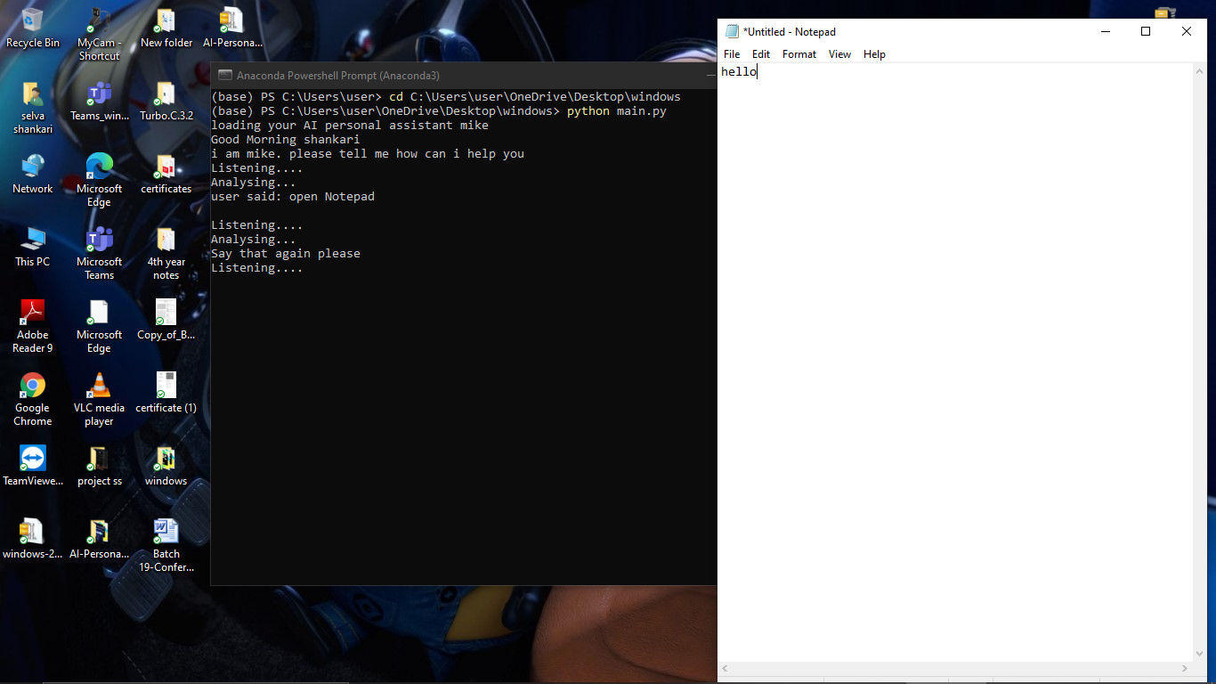

**Command –“open youtube”**

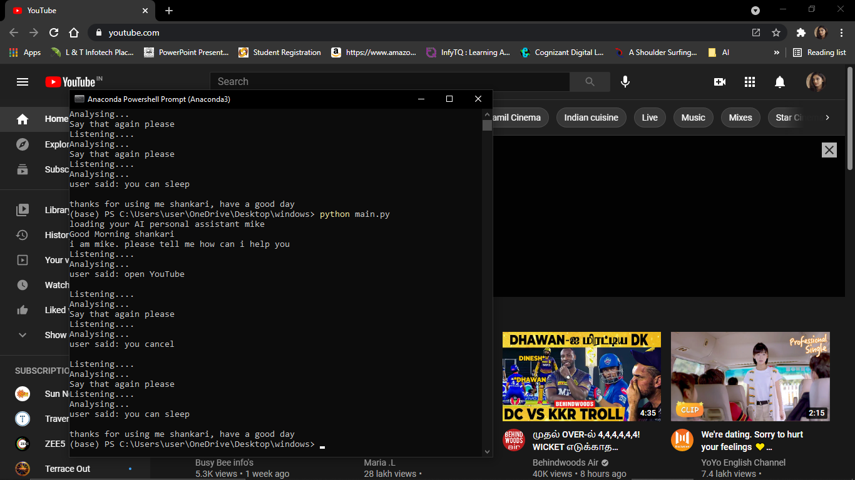

**Command –“open cmd”**

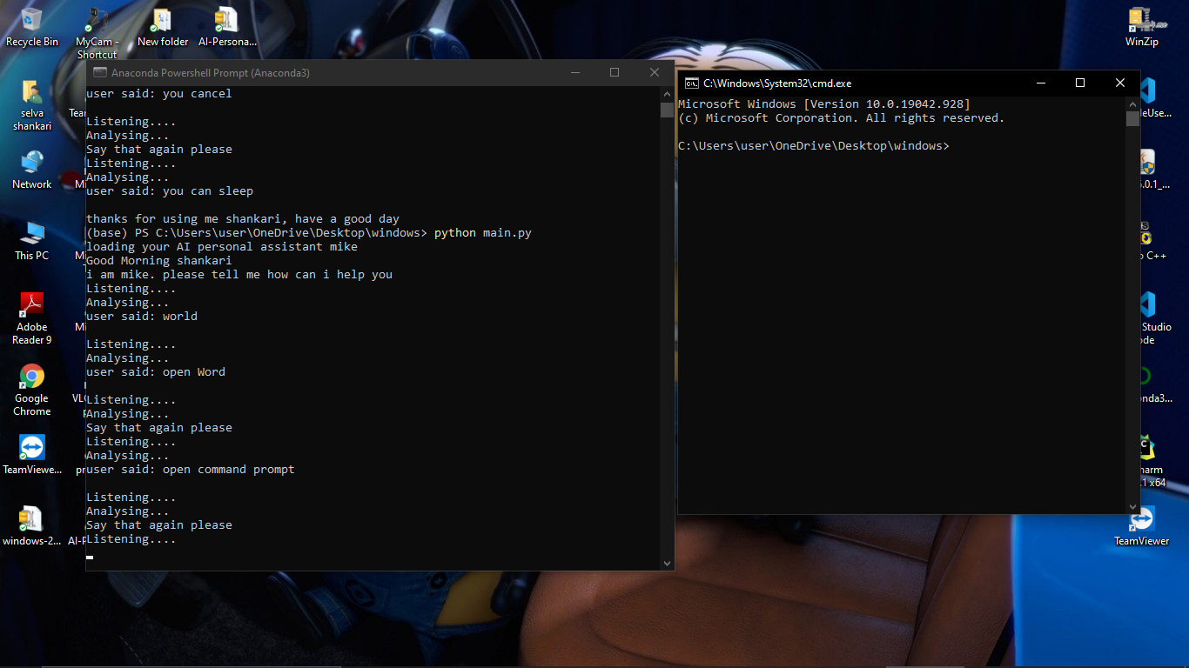

**Command – “ play music”**

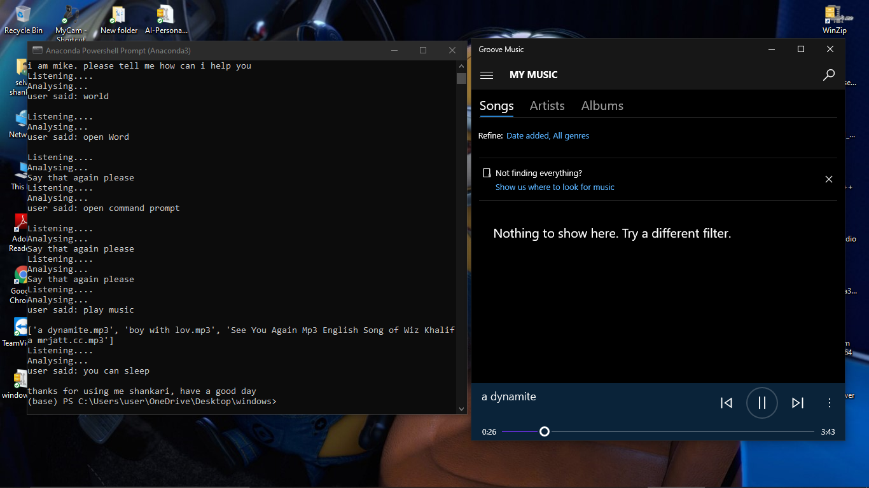

**Command –“ Ip address”**

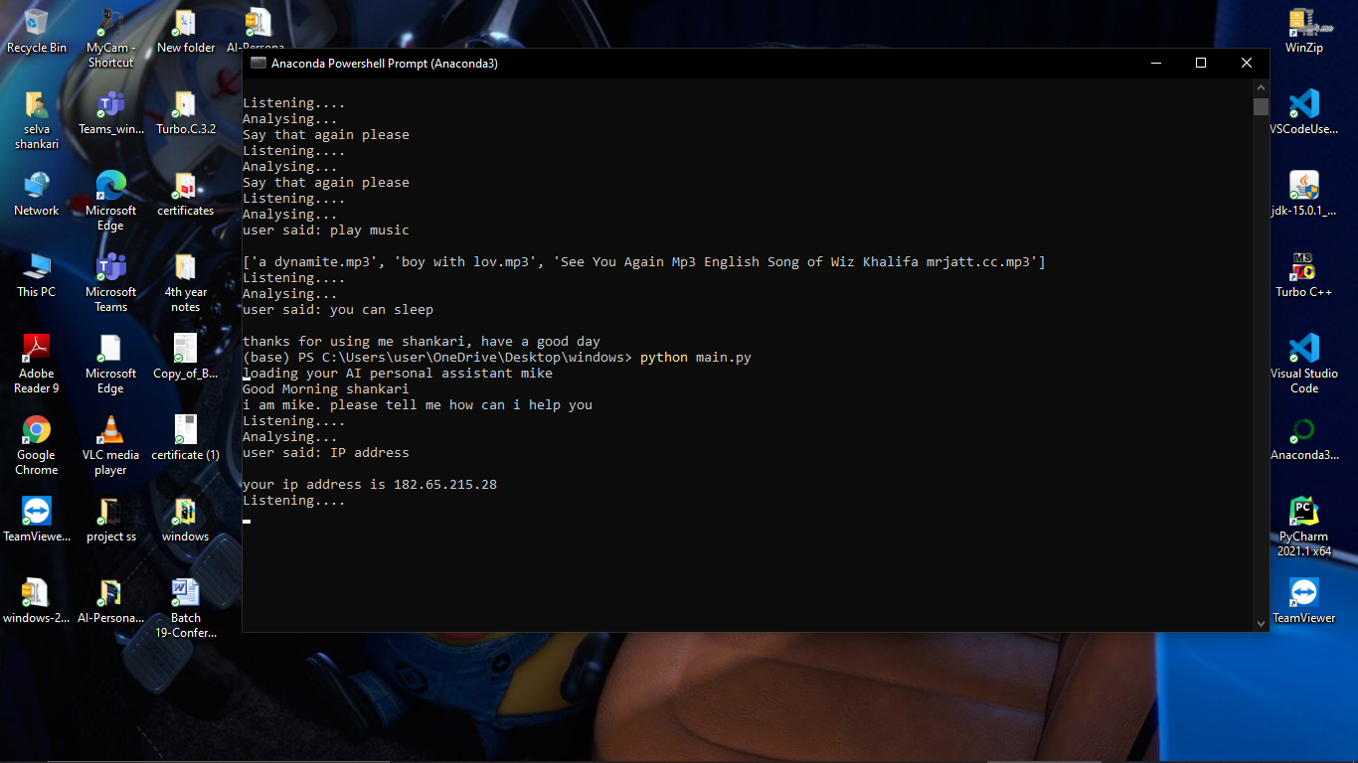

**Command –“wikipedia”**

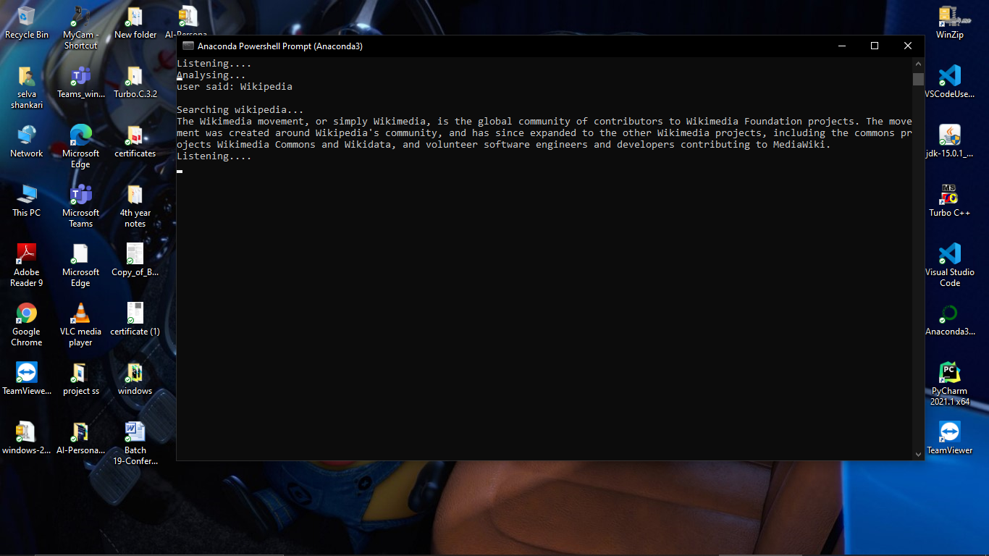

**Command –“open google”**

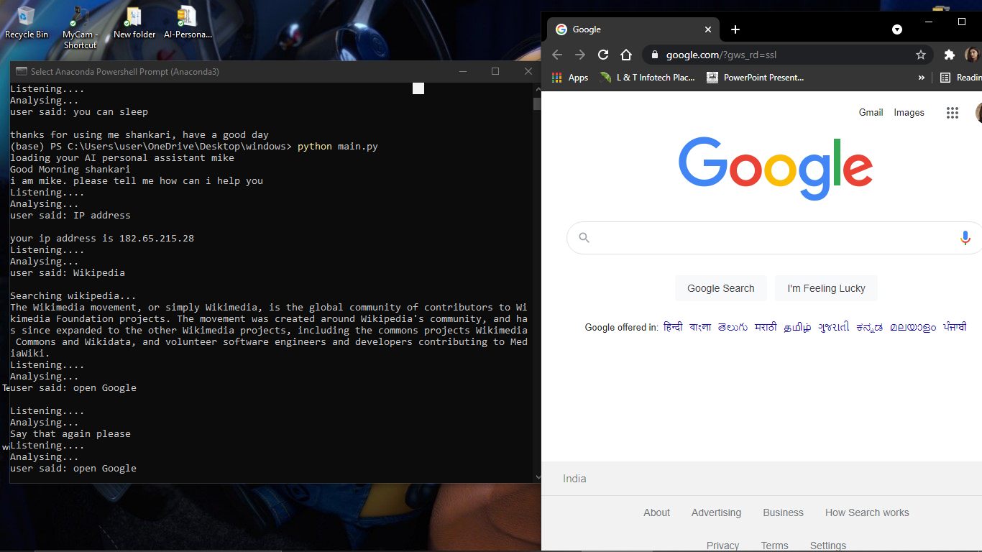

**Command –“search google”**

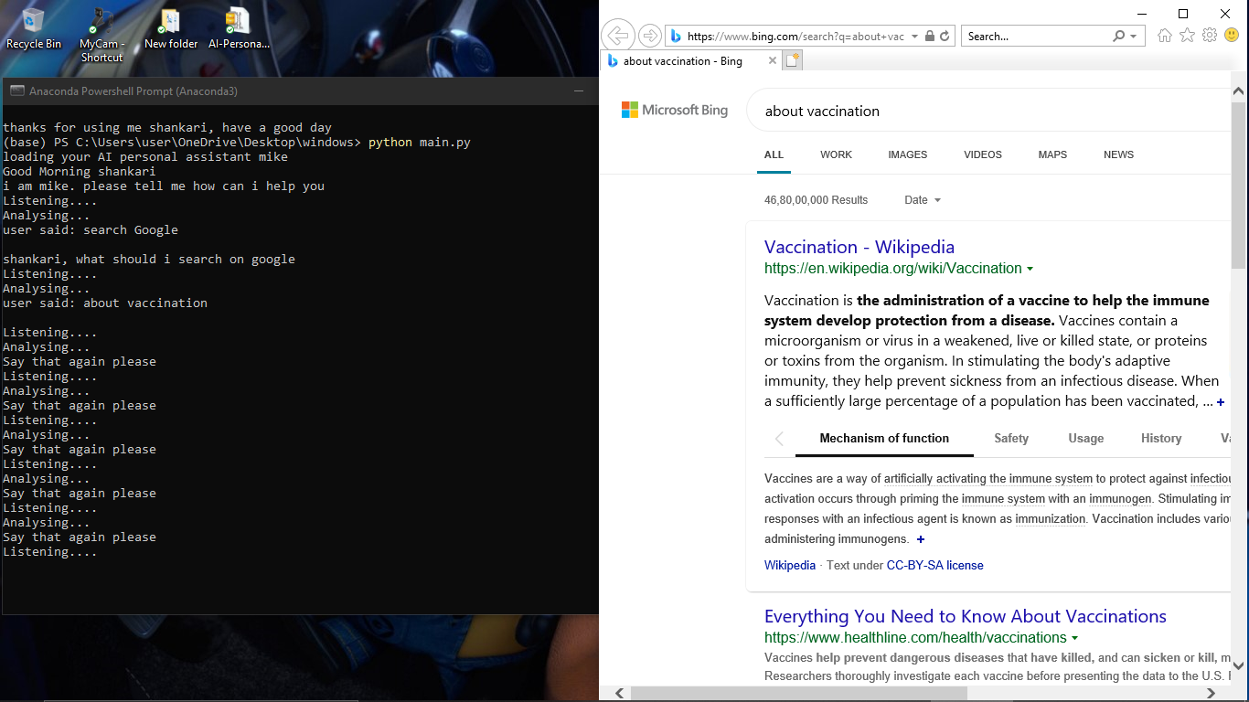

**Command –“open instagram”**

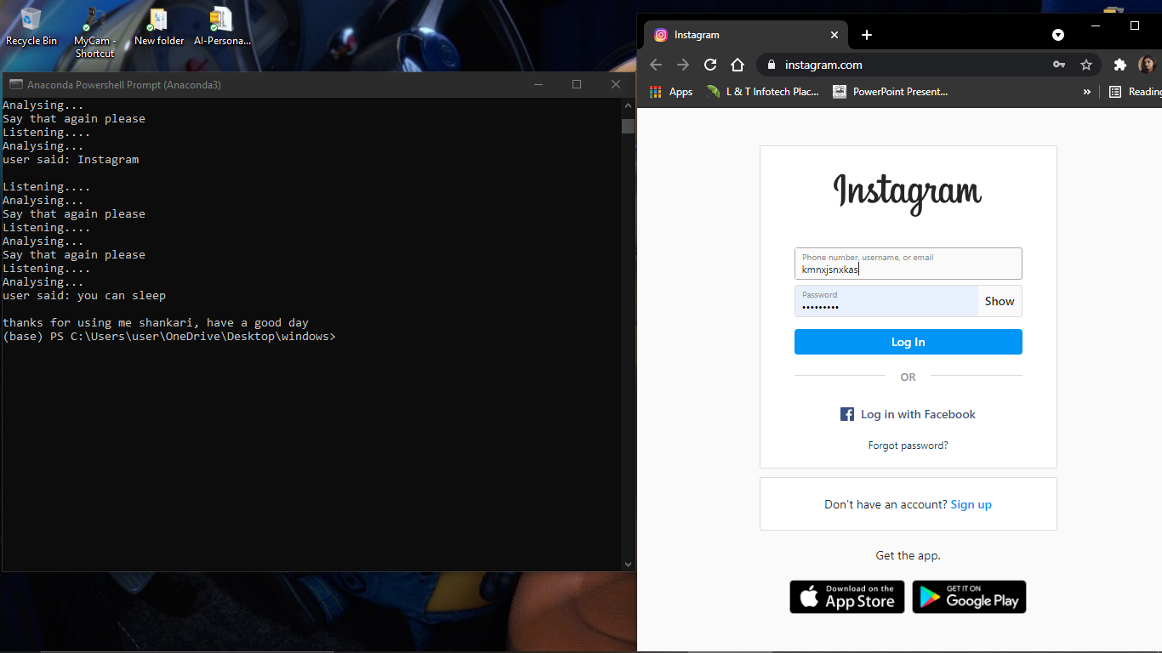

**Command – “open reddit”**

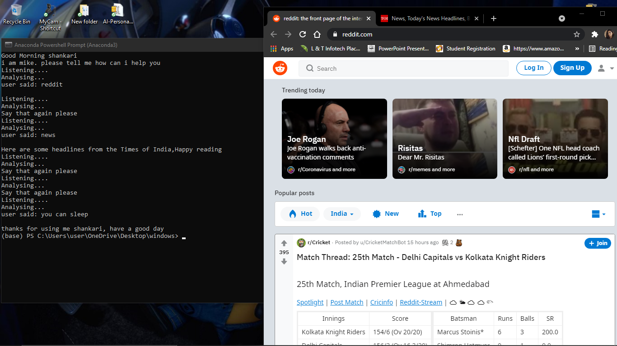

**Command –“news”**

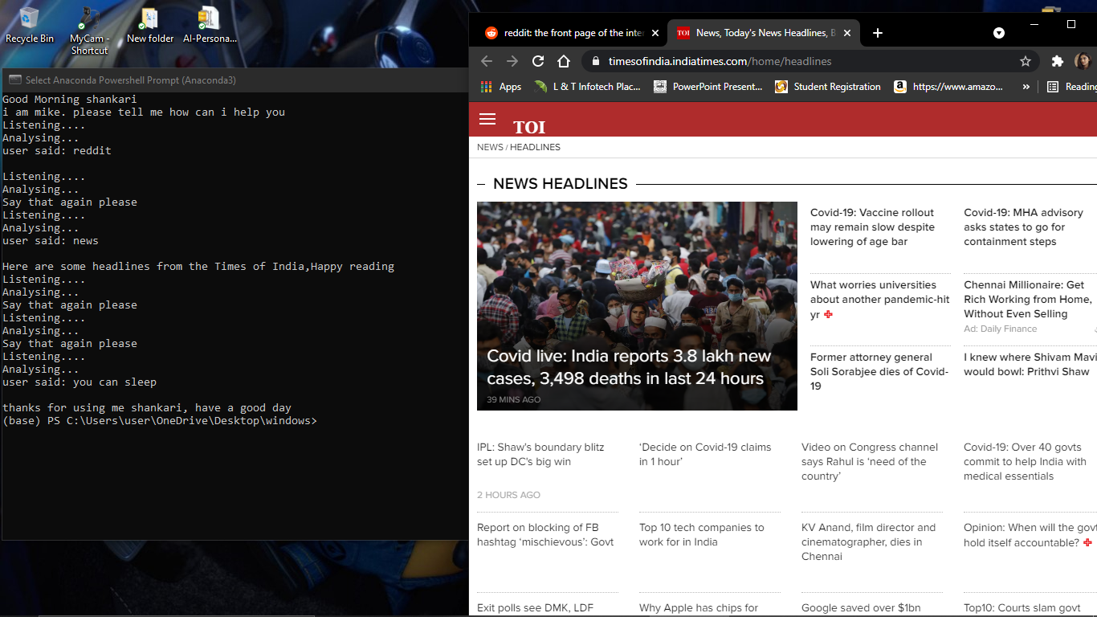

Command – “time”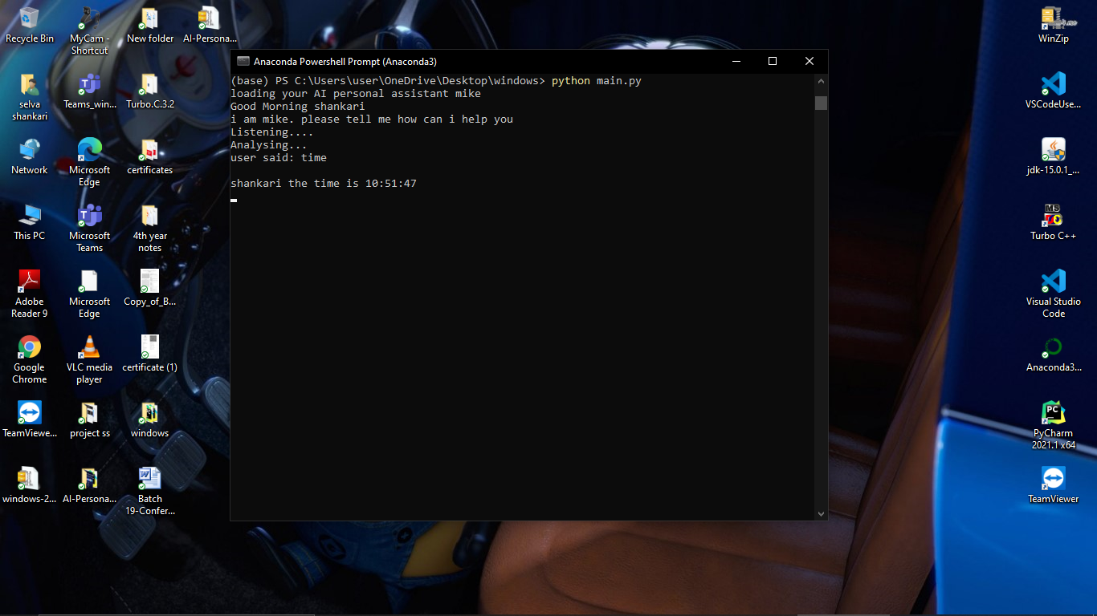

**Command –“how are you”**

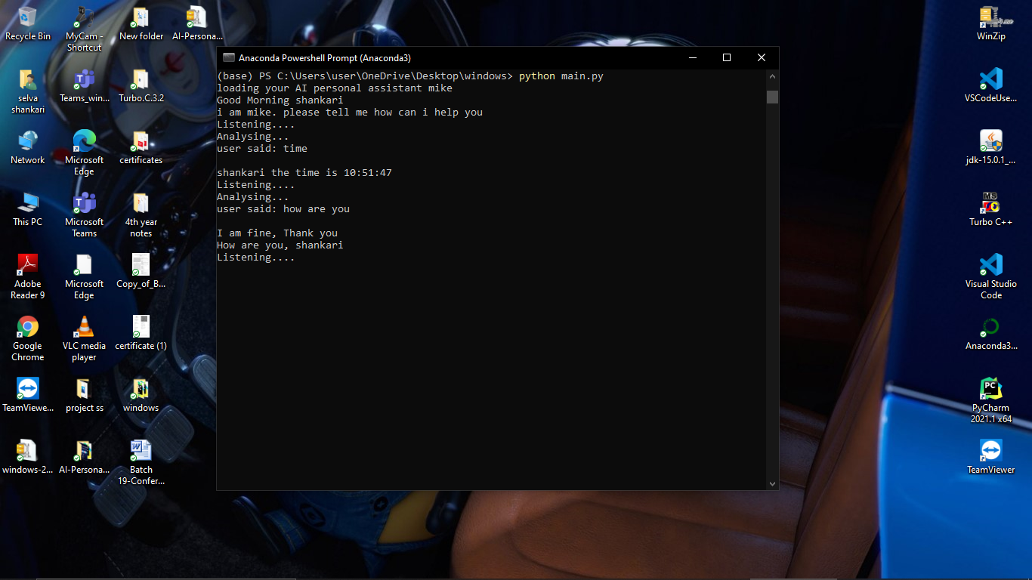

Command – “fine"

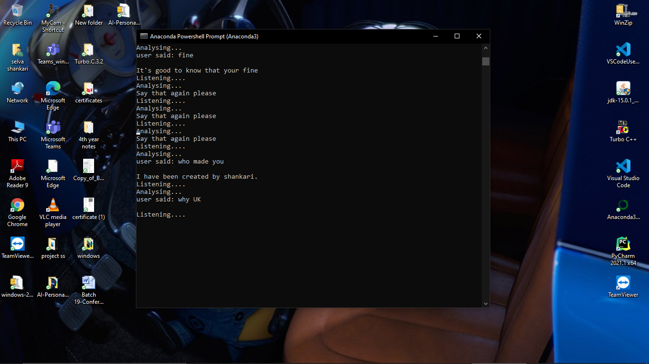

Command – “ why you came to world”

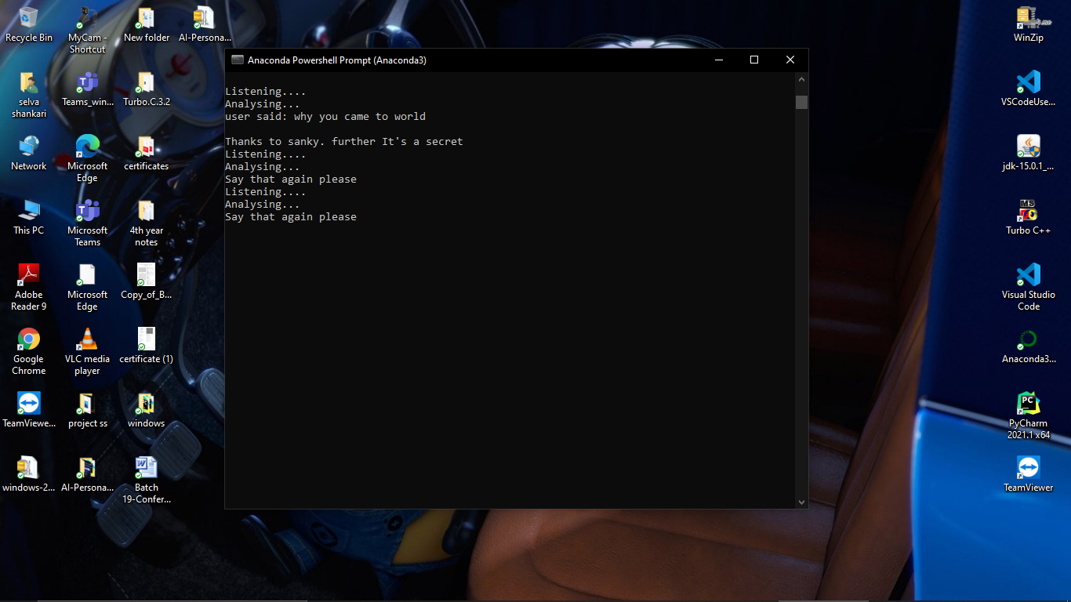

**Command – “ tell me a joke”**

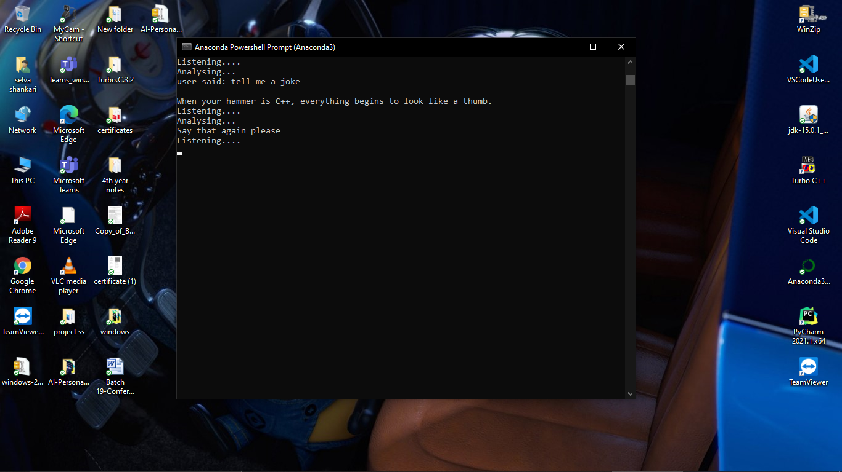

**Command – “empty recycle bin”**

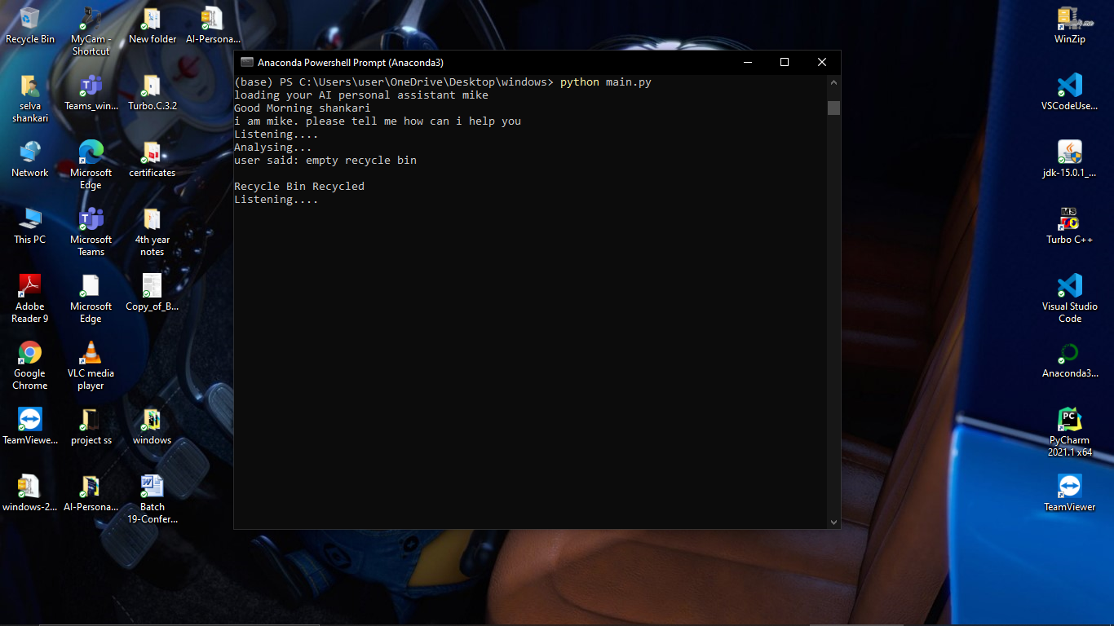

**Command – “email to mala”**

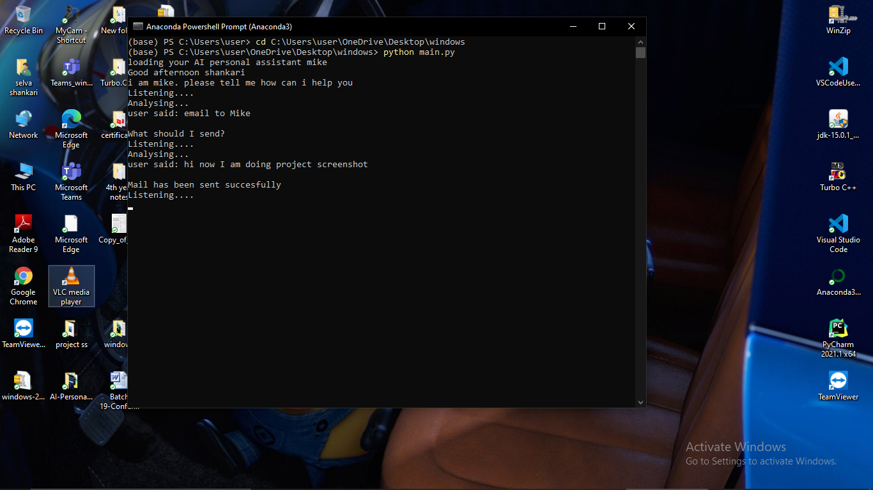

**Command to stop AI assistant – “you can sleep”**

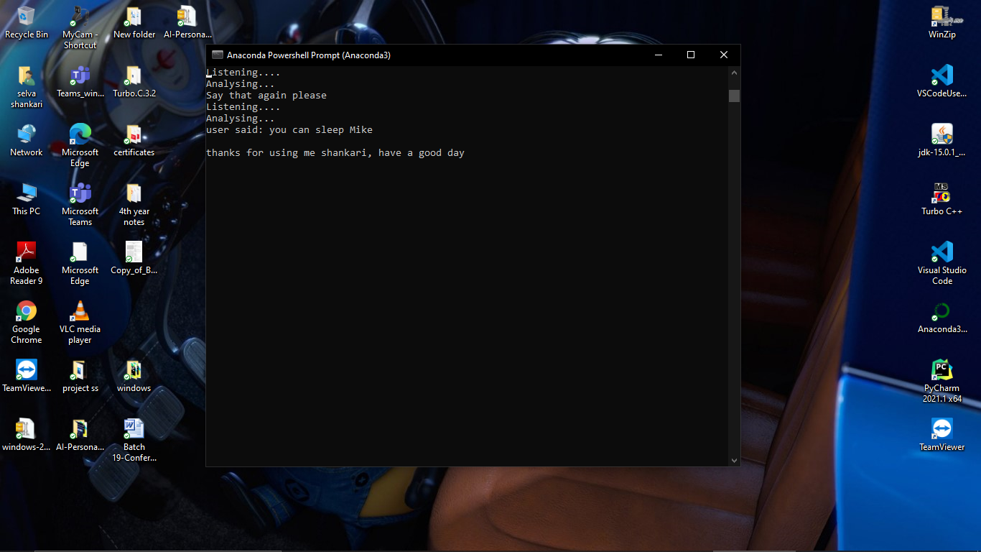

**A.2 PUBLICATION**

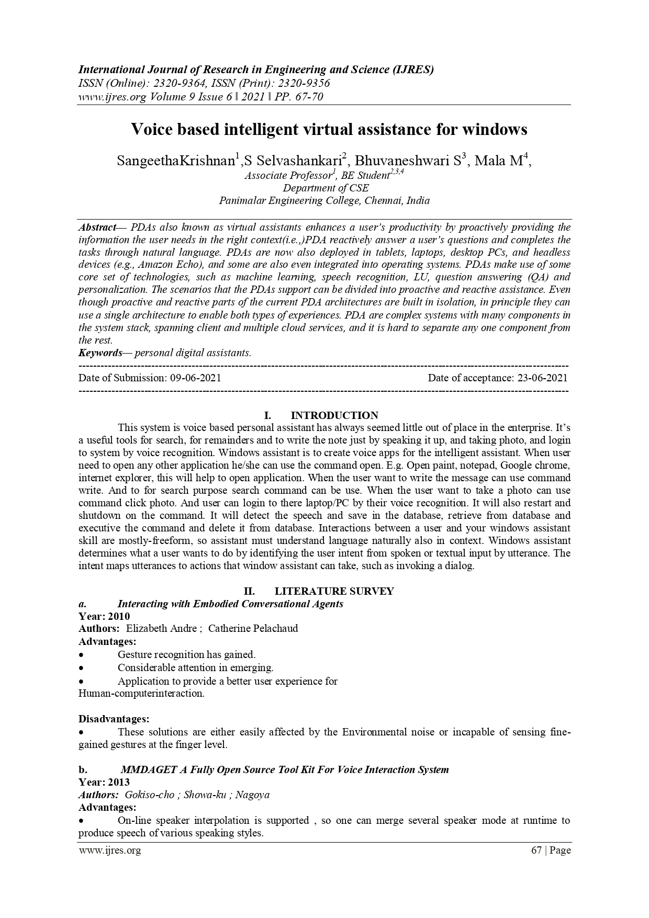

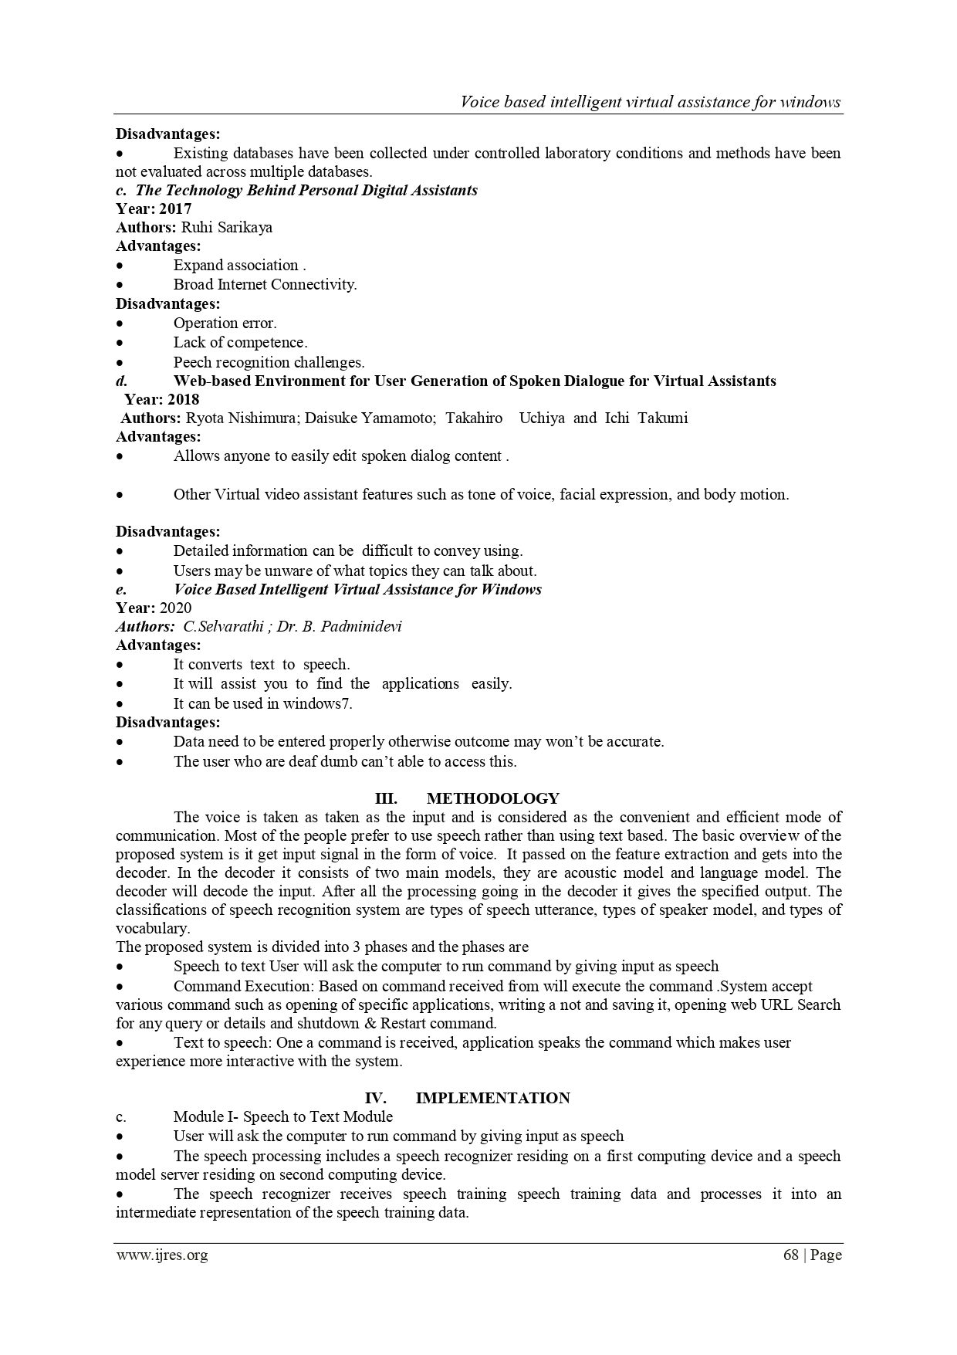

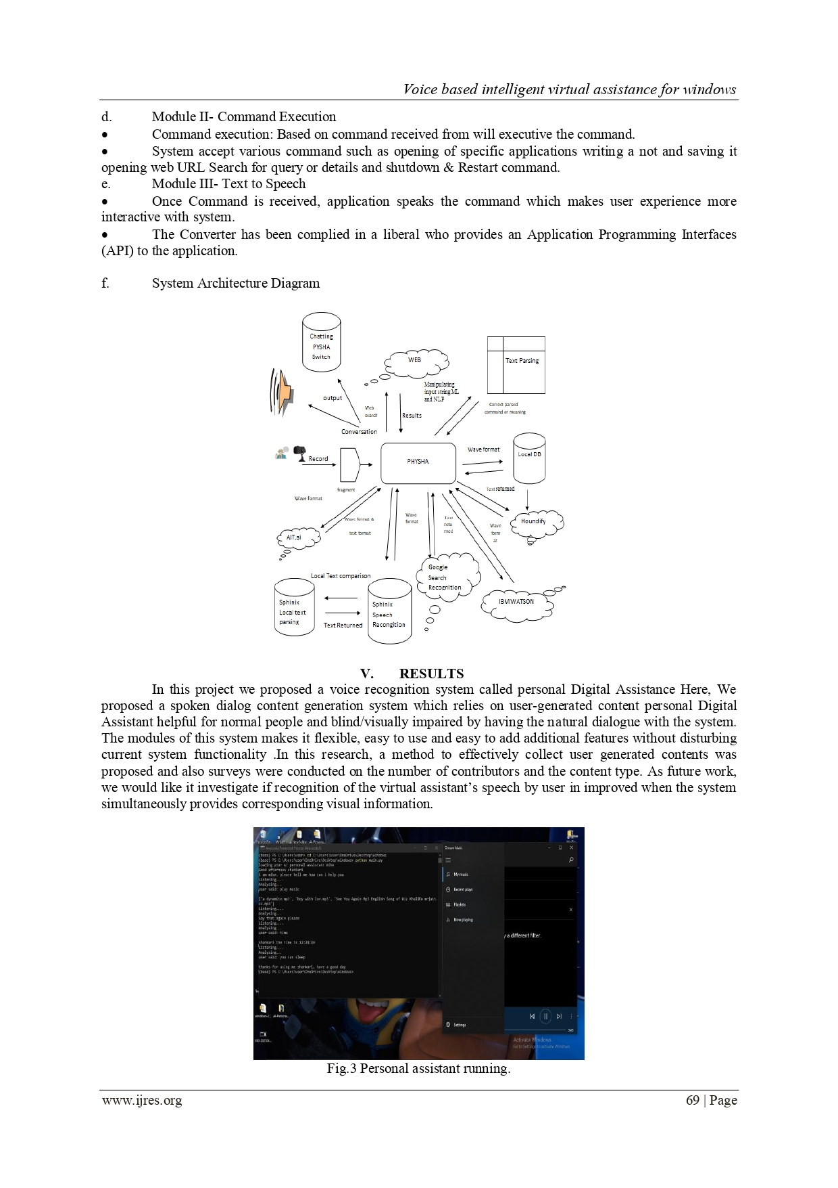

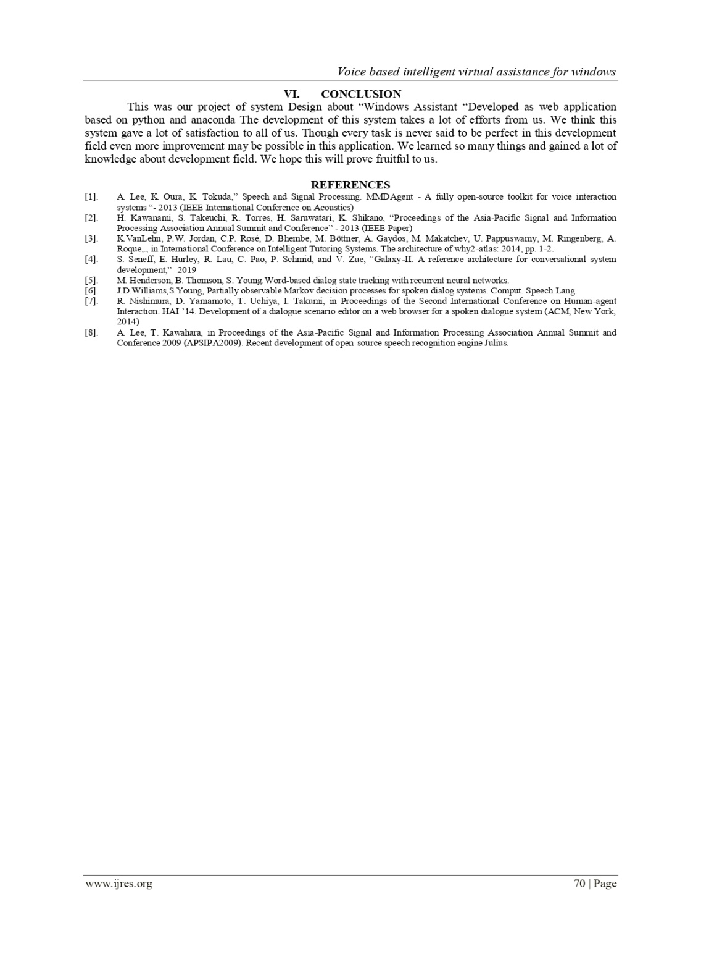

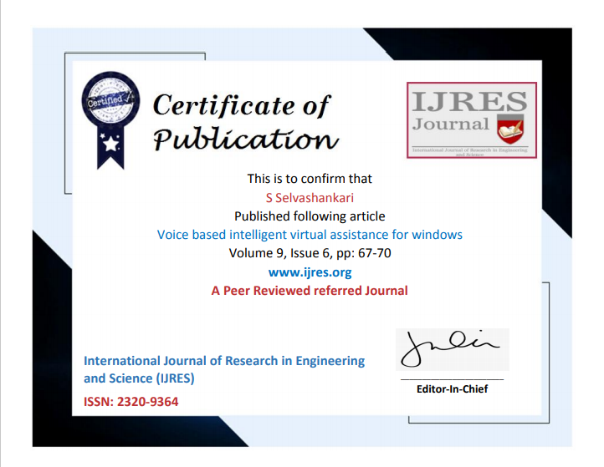

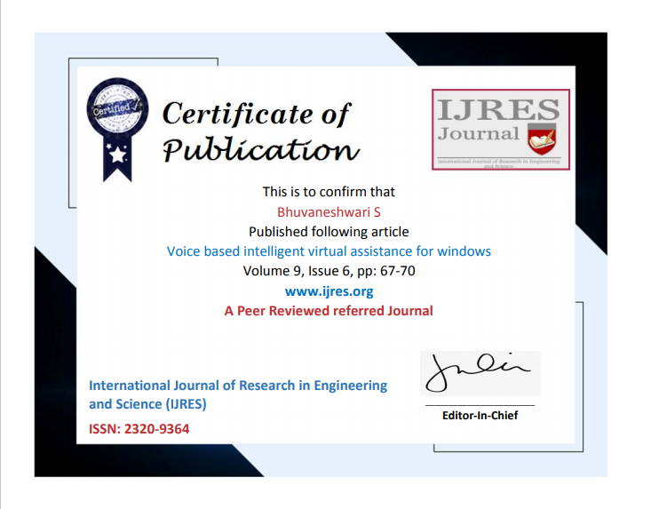

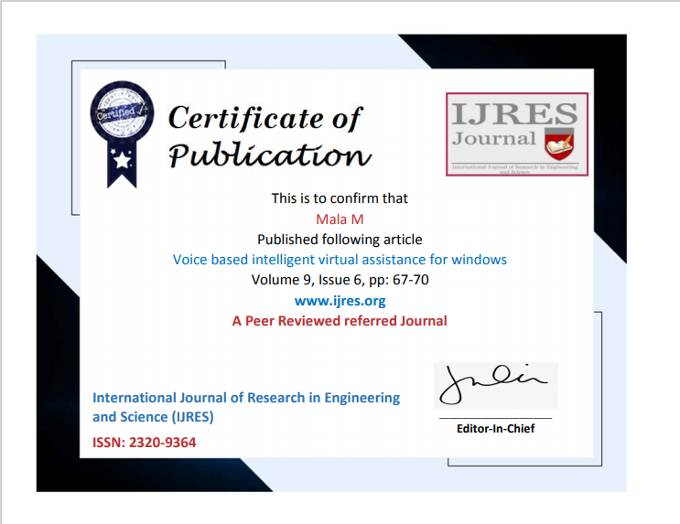

**REFERENCES**

1 .A. Lee, K. Oura, K. Tokuda, in 2013 IEEE International Conference on Acoustics, Speech and Signal Processing. MMDAgent - A fully open-source toolkit for voice interaction systems

2. H. Kawanami, S. Takeuchi, R. Torres, H. Saruwatari, K. Shikano, in Proceedings of the Asia-Pacific Signal and Information Processing Association Annual Summit and Conference

3. K. VanLehn, P.W. Jordan, C.P. Rosé, D. Bhembe, M. Böttner, A. Gaydos, M. Makatchev, U. Pappuswamy, M. Ringenberg, A. Roque, et al., in International Conference on Intelligent Tutoring Systems. The architecture of why2-atlas:

4. S. Seneff, E. Hurley, R. Lau, C. Pao, P. Schmid, and V. Zue, “Galaxy-II: A reference architecture for conversational system development,”

5. M. Henderson, B. Thomson, S. Young. Word-based dialog state tracking with recurrent neural networks.

6. J.D. Williams, S. Young, Partially observable Markov decision processes for spoken dialog systems. Comput. Speech Lang.

7. M. Henderson, B. Thomson, S. Young. Word-based dialog state tracking with recurrent neural networks

8. R. Nishimura, D. Yamamoto, T. Uchiya, I. Takumi, in Proceedings of the Second International Conference on Human-agent Interaction. HAI ’14. Development of a dialogue scenario editor on a web browser for a spoken dialogue system (ACM, New York, 2014) HTS Working Group, Open JTalk: The Japanese TTS System

9. A. Lee, T. Kawahara, in Proceedings of the Asia-Pacific Signal and Information Processing Association Annual Summit and Conference 2009 (APSIPA2009). Recent development of open-source speech recognition engine julius